**Quantitative Methods**

**List of Exercises N. 7**

**Selected Exercises from McClave (2014) – Chapter 11**

**11.1 Probabilistic Models**

**Exercise 1. (5, 6, 7). Plot the following lines and give their slopes and intercepts. Why do we generally prefer a probabilistic model to a deterministic model? Give examples for when the 2 types of models might be appropriate.**

First, we need to clean the script.

Clean the script: rm(list=ls())

In order to graph a line 2 points that are part of the graph are necessary. Therefore, we can pick 2 different (random) values for x to find the corresponding y values be solving the equation and then plot the line. We chose (0, 2).

The y intercept is the value of y when x equals zero. The slope of a line is a measure of the "stepness" of the line. The slope of a line can be computed from any two points on the line. Slope=(y(1)-y(2)/(x(1)-x(2))).

Remember to apply to the regressions.

This is an answer to exercise 1, part 5 and 6. See part 7 further below.

**a) y = 4 + x**

When x=0, we call it y_1a:

y=4+x

y_la = 4+0 = 4

The first point on the graph is then (0,4)

When x=2, we call it y_1b:

y=4+x

y_1b=4+2=6

The second point on the graph is (2,6)

x_a<-c(0,4)

y_a<-c(2,6)

Making the plot:

plot(x_a, y_a, main="Scatterplot of y=4+x", xlab="x", ylab="y", type="o", col="blue")

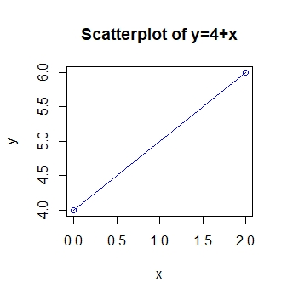

Slope: slope_a=(4-6)/(0-2)

When y=4+x, then the slope is beta(1)=1, The y-intercept is beta(0)=4.

We do this again for each of the remaining exercises:

**b) y = 5 - 2x**

y=5-2x

y=5-(2*0)=5

y=5-(2*2)=1

x_b<-c(0,2)

y_b<-c(5,1)

Making the plot:

plot(x_b, y_b, main="Scatterplot of y=5-2x", xlab="x", ylab="y", type="o", col="blue")

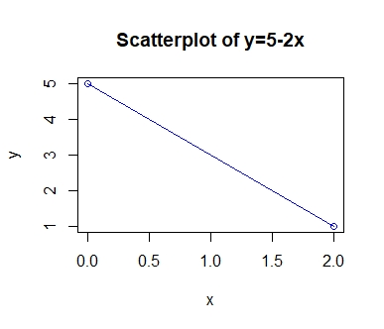

Slope:

slope_b=(5-1)/(0-2)

When y=5-2x, then the slope is beta(1)=-2, The y-intercept is beta(0)=5.

**c) y = - 4 + 3x**

y=-4+3x

y=-4+3*0

y=-4+3*2

x_c<-c(0,2)

y_c<-c(-4,2)

Making the plot:

plot(x_c, y_c, main="Scatterplot of y=-4+3x", xlab="x", ylab="y", type="o", col="blue")

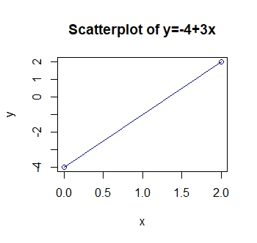

Slope:

slope_c=(-4-2)/(0-2)

When y=-4+3x, then the slope is beta(1)=3, The y-intercept is beta(0)=-4.

**d) y = - 2x**

y=-2x

y=2*0

y=2*2

x_d<-c(0,2)

y_d<-c(0,-4)

Plot:

plot(x_d, y_d, main="Scatterplot of y=-2x", xlab="x", ylab="y", type="o", col="blue")

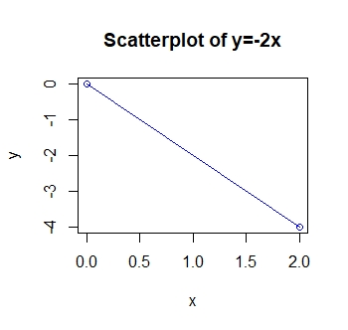

Slope:

slope_d=(0-(-4))/(0-2)

When y=-2x, then the slope is beta(1)=-2, The y-intercept is beta(0)=0.

**e) y = x**

y=x

y=0

y=2

x_e<-c(0,2)

y_e<-c(0,2)

Plot:

plot(x_e, y_e, main="Scatterplot of y=x", xlab="x", ylab="y", type="o", col="blue")

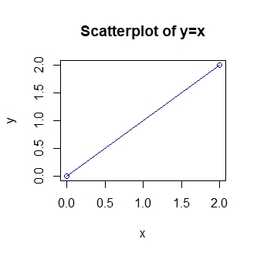

Slope:

slope_e=(0-2)/(0-2)

When y=x, then the slope is beta(1)=1, The y-intercept is beta(0)=0.

**f) y = 0.50 + 1.5x**

y=0.5+1.5x

y=0.5+1.5*0

y=0.5+1.5*2

x_f<-c(0,2)

y_f<-c(.5,3.5)

Plot:

plot(x_f, y_f, main="Scatterplot of y=0.50+1.5x", xlab="x", ylab="y", type="o", col="blue")

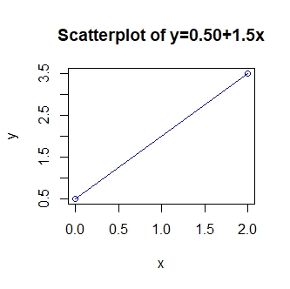

Slope:

slope_f=(0.50-3.5)/(0-2)

When y=0.5+1.5x, then the slope is beta(1)=1.5, The y-intercept is beta(0)=5.

Answer to Exercise 1, part 7:

A deterministic model does not allow for random error or variation, whereas a probabilistic model does. An example where a deterministic model would be appropriate is:

Let y=cost of a 2x4 piece of lumber and x= length (in feet).

The model would be $y=β_{1}x$. There should be no variation in price for the same length of wood.

An example where a probabilistic model would be appropriate is:

Let y=sales per month of a commodity and x=amount of money spent advertising.

The model would be $=β_{0}+β_{1}x+ϵ$. The sales per month will probably very even if the amount of money spent on advertising remains the same.

**Exercise 2. (9). If a straight-line probabilistic relationship related the mean E(y) to an independent variable x, does it imply that every value of the variable y will always fall exactly on the line of means? Why or why not?**

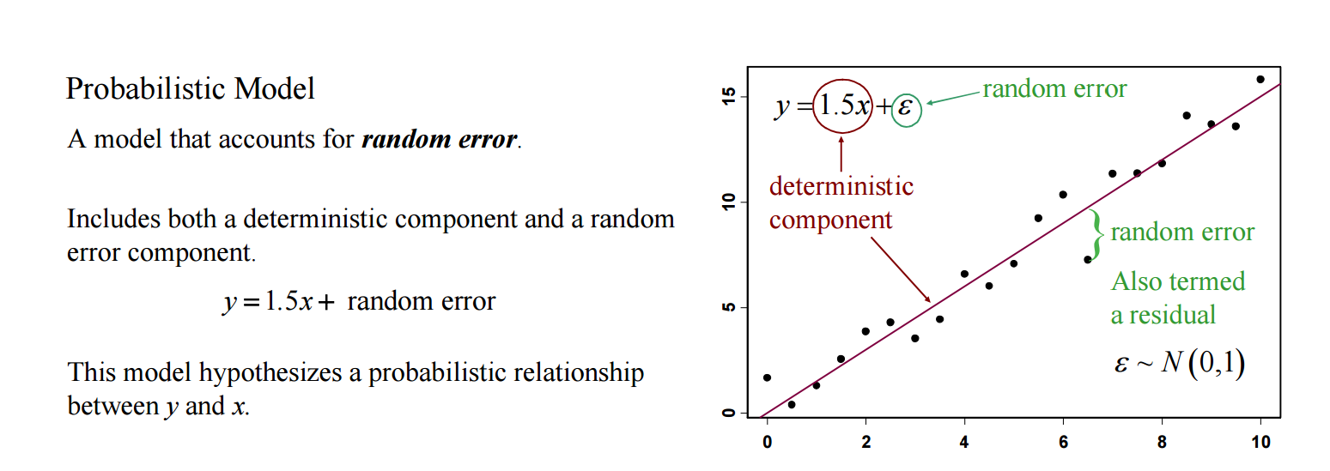No. The random error component, $ε$, allows the values of the variable to fall above or below the line.

**Probailistic model:**

A model that accounts for random error.

Includes both a deterministic component and a random error component.

Y=1.5x+random error

This model hypothesizes a probabilistic relationship between y and x.

**11.2 Fitting the Model: The Least Squares Approach**

**Exercise 3. (10, 11). The following table is used for making the preliminary computations for finding the least squares line for the given pairs of x and y values.**

|  |  |  |  |  |
| --- | --- | --- | --- | --- |
|  | **Xi** | **Yi** | **Xi2** | **Xi Yi** |
|  | **7** | **2** |  |  |
|  | **4** | **4** |  |  |
|  | **6** | **2** |  |  |
|  | **2** | **5** |  |  |
|  | **1** | **7** |  |  |
|  | **1** | **6** |  |  |
|  | **3** | **5** |  |  |
| **Totals** | **ΣXi=** | **ΣYi =** | **ΣXi2 =** | **Σ Xi Yi =** |

First, we need to do as followed:

1. Clean your screen
2. Run Library(mosaic)
3. Import data
4. Create variables

For explanation how to do this look at List 1, Exercise 1.

Clean the R Script: rm(list=ls())

Library: library(mosaic)

We can either create the data and values:

xi<-c(7,4,6,2,1,1,3)

yi<-c(2,4,2,5,7,6,5)

n<-c(7)

Or import the data:

library(readxl)

L7E3 <- read_excel("~/SDC/Quantitative Research Methods Course/Exercises/Dataset/List7/L7E3.xlsx")

View(L7E3)

attach(L7E3)

xi <- xi

yi <- yi

1. **Complete the table.**

We should now calculate each of the variables, that are missing values:

xi^2

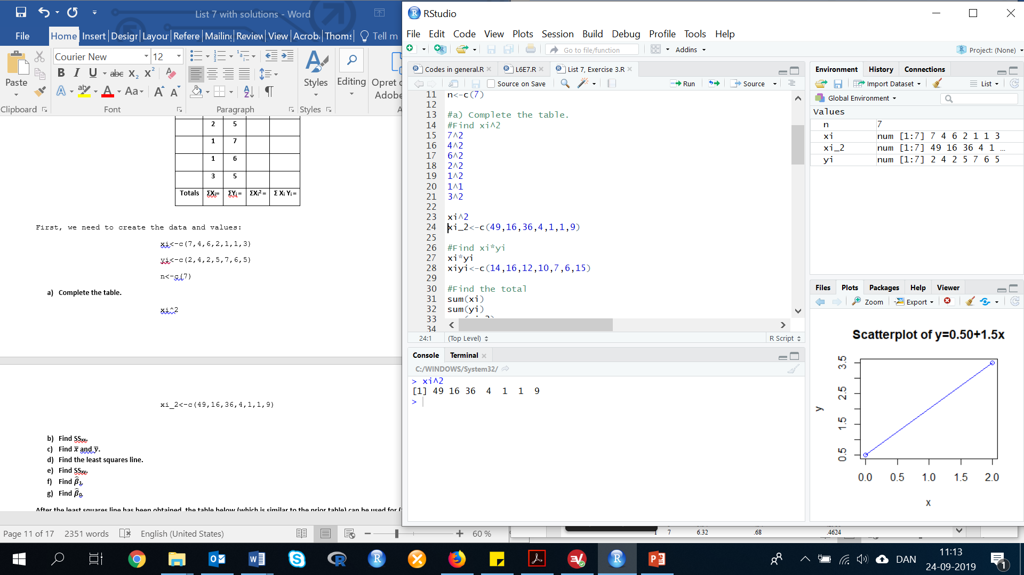

xi_2<-c(49,16,36,4,1,1,9)

xi*yi

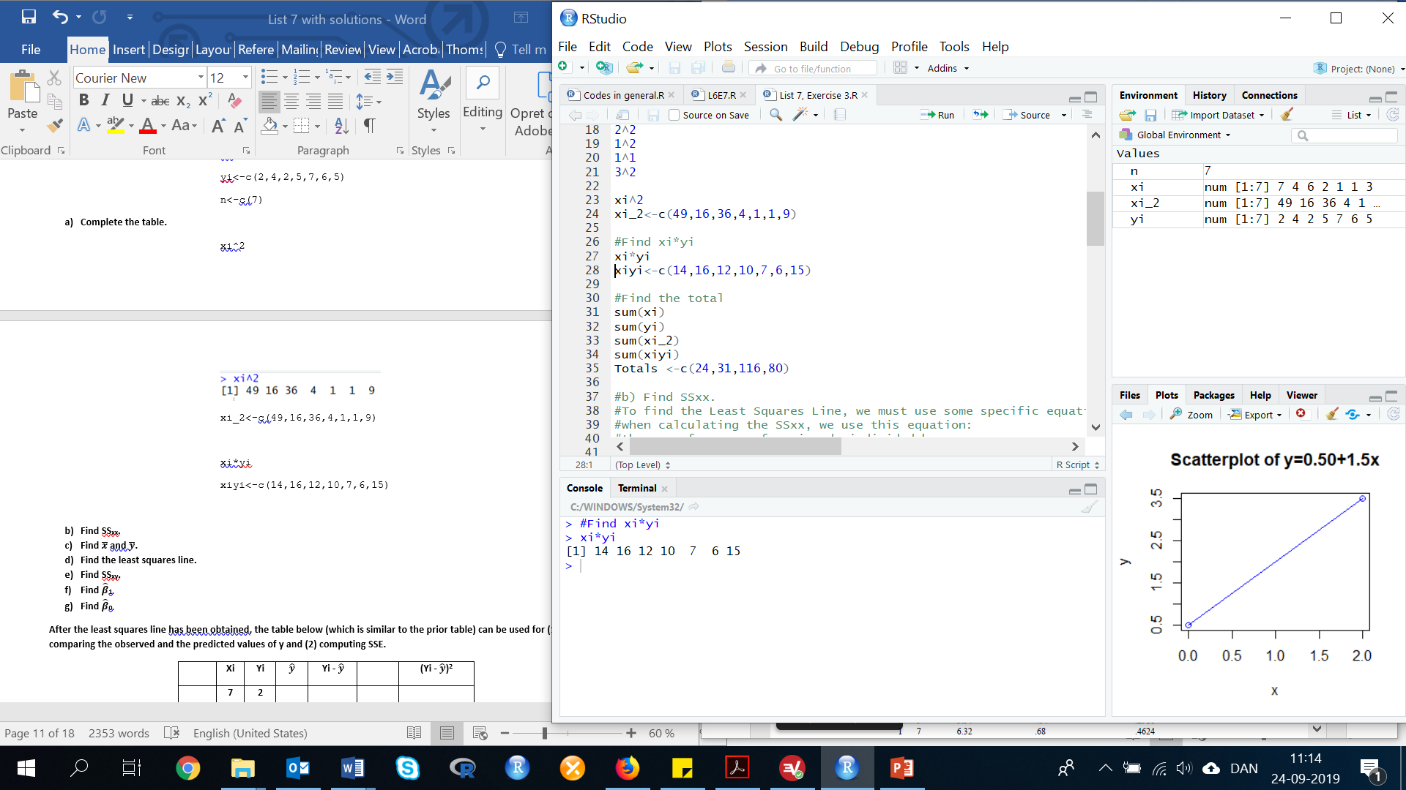

xiyi<-c(14,16,12,10,7,6,15)

Calculate the totals:

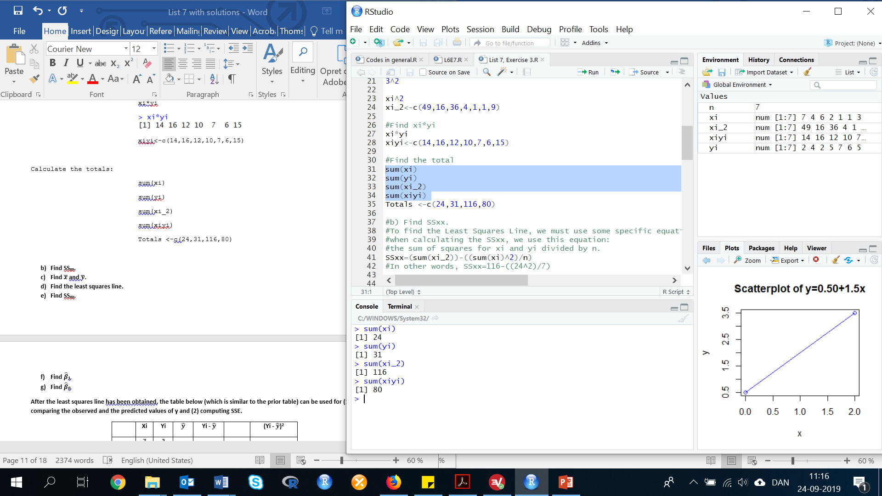sum(xi)

sum(yi)

sum(xi_2)

sum(xiyi)

Totals <-c(24,31,116,80)

1. **Find SSxx.**

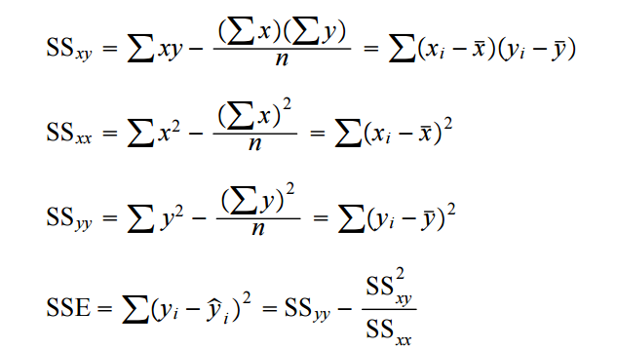

SSxx <- 116-(((24)^2)/7)

SSxx = 33.71429

1. 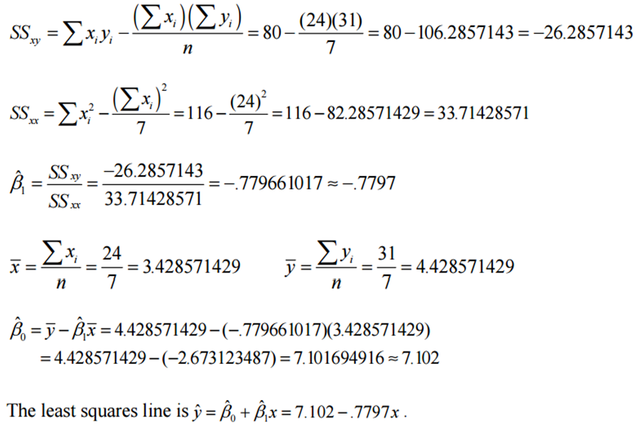**Find $\overline{x}$ and $\overline{y}$.**



sum_xi/n

sum_yi/n

In other words, $\overline{x}$ =24/7 and $\overline{y}$ =31/7.

Results: $\overline{x}$ =3.428571

$\overline{y}$ =4.428571

1. **Find the least squares line.**



We use the information from List 7, Exercise 3 part f and g.

$\hat{y}$ =7.101694951525424-0.779661016949153x

But, we could also just use the lm() function, and make a regression analysis:

Reg<-lm(formula=yi ~ xi, data = L7E3)

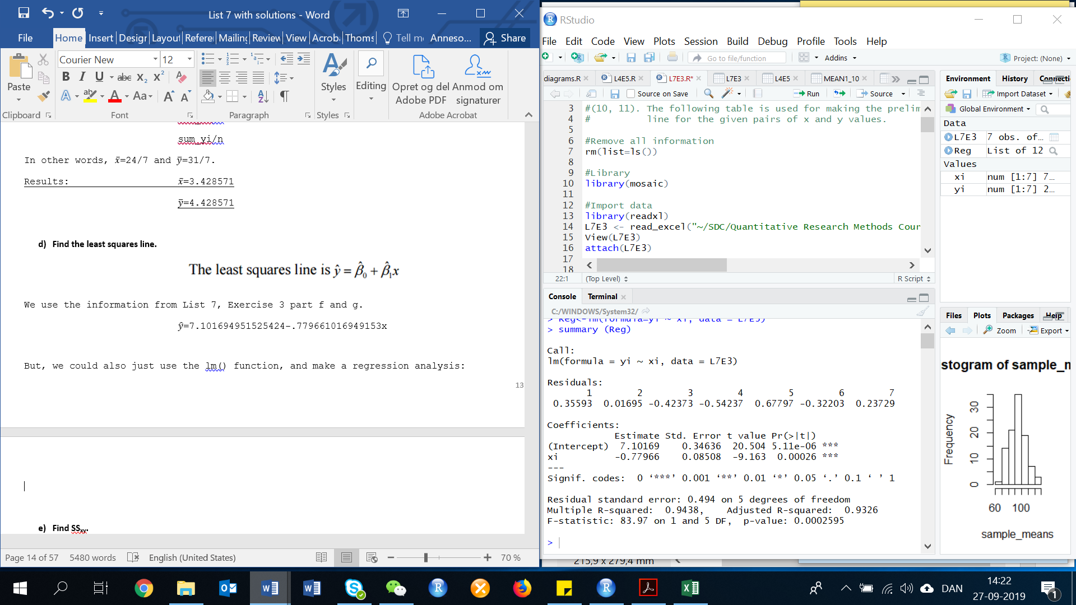summary (Reg)

By looking at this analysis, we can see that:

$\hat{y}$ =7.10169-0.77966x

1. **Find SSxy.**

SSxy is just the sum of squares for Xi & Yi dived by hence we get the above equation when filling it in.

SSxy=(sum(xiyi))-((sum(xi)*sum(yi))/n)

In other words, SSxy=80-((24*31)/7)

SSxy = -26.28571

1. **Find 1.**

With SSxx and SSxy, we then can find ${\hat{β}}_{1}$:

B_1=SSxy/SSxx

In other words, B_1=-26.28571/33.71429

B_1=-0.779661

Or we can look at the regression analysis in part d, and we will see that B1=-0.77966.

1. **Find 0.**

B_0=y_bar-(B_1*x_bar)

In other words, B_0=4.428571-(-0.779661*3.428571)

B_0=7.101694

Or we can look at the regression analysis in part d, and we will see that B0=7.10169.

**After the least squares line has been obtained, the table below (which is similar to the prior table) can be used for (1) comparing the observed and the predicted values of y and (2) computing SSE.**

|  |  |  |  |  |  |  |
| --- | --- | --- | --- | --- | --- | --- |
|  | **Xi** | **Yi** |  | **Yi -** |  | **(Yi - )2** |
|  | **7** | **2** |  |  |  |  |
|  | **4** | **4** |  |  |  |  |
|  | **6** | **2** |  |  |  |  |
|  | **2** | **5** |  |  |  |  |
|  | **1** | **7** |  |  |  |  |
|  | **1** | **6** |  |  |  |  |
|  | **3** | **5** |  |  |  |  |
|  |  |  |  | **Σ(Yi - ) =** |  | **SSE = Σ(Yi - )2 =** |

1. **Complete the table.**

y_hat=7.101694951525424-(.779661016949153*xi)

y_hat

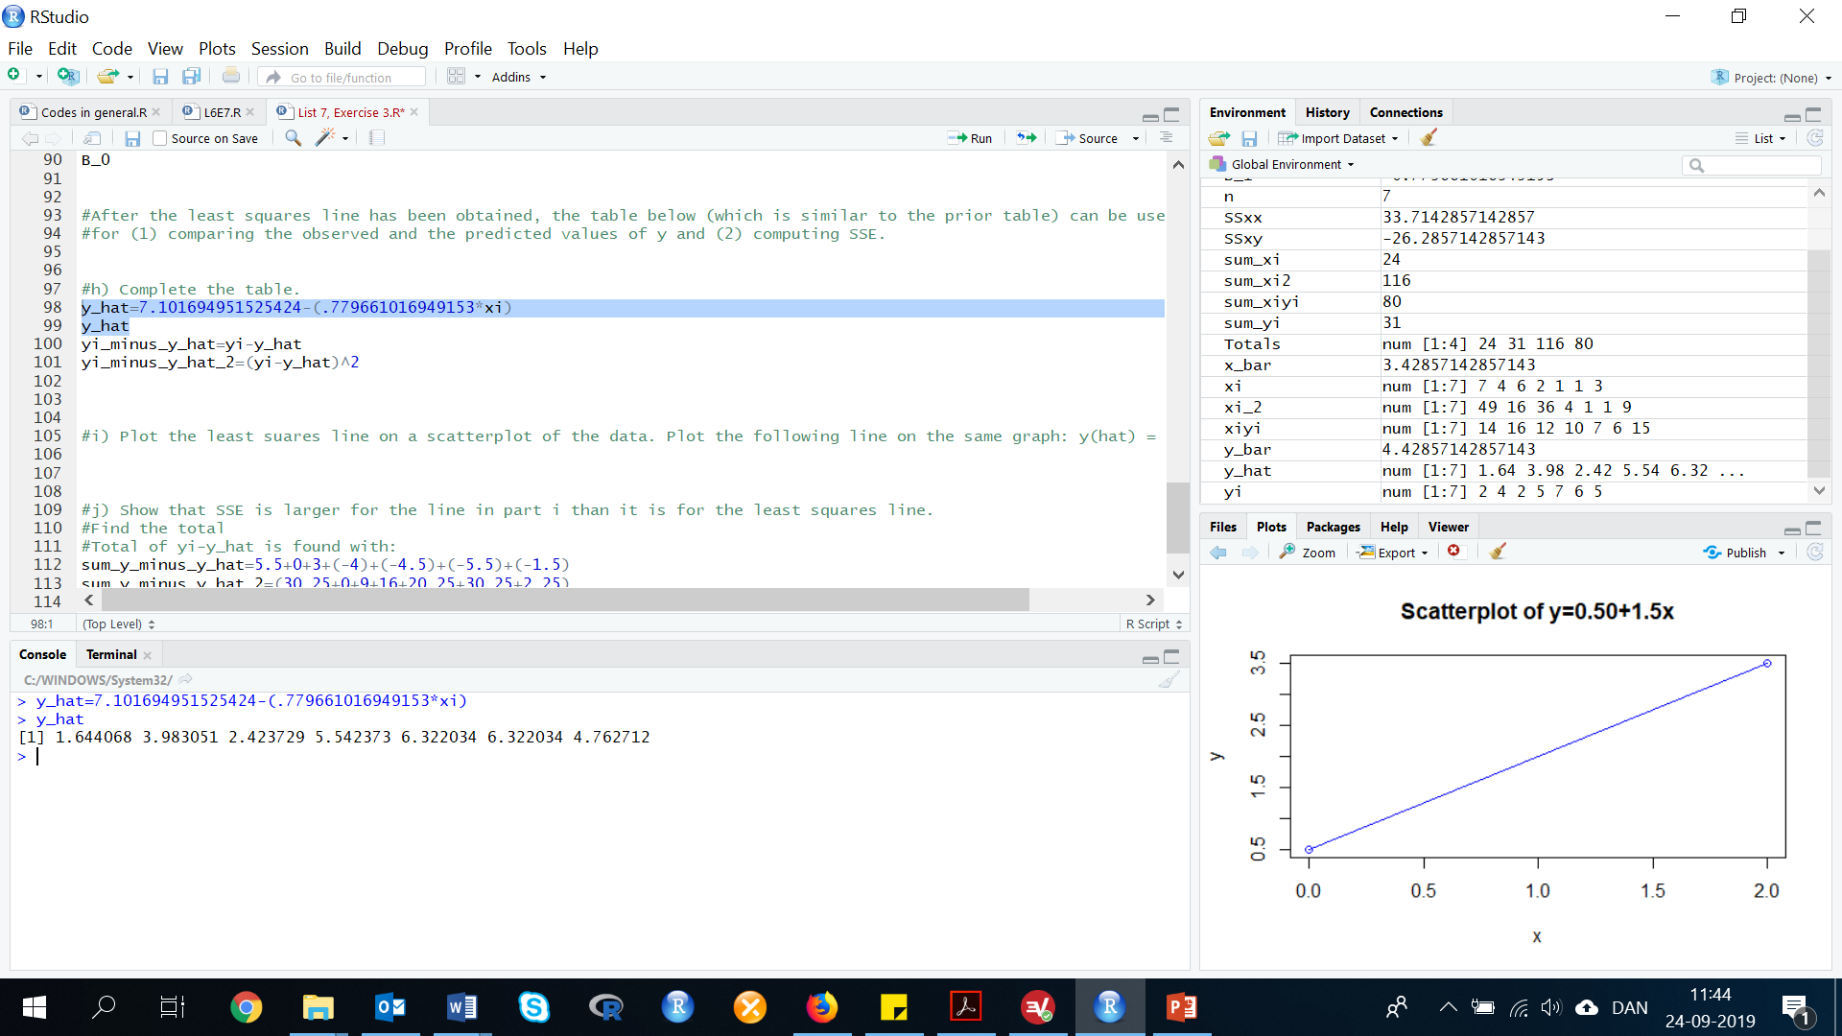

yi_minus_y_hat=yi-y_hat

yi_minus_y_hat

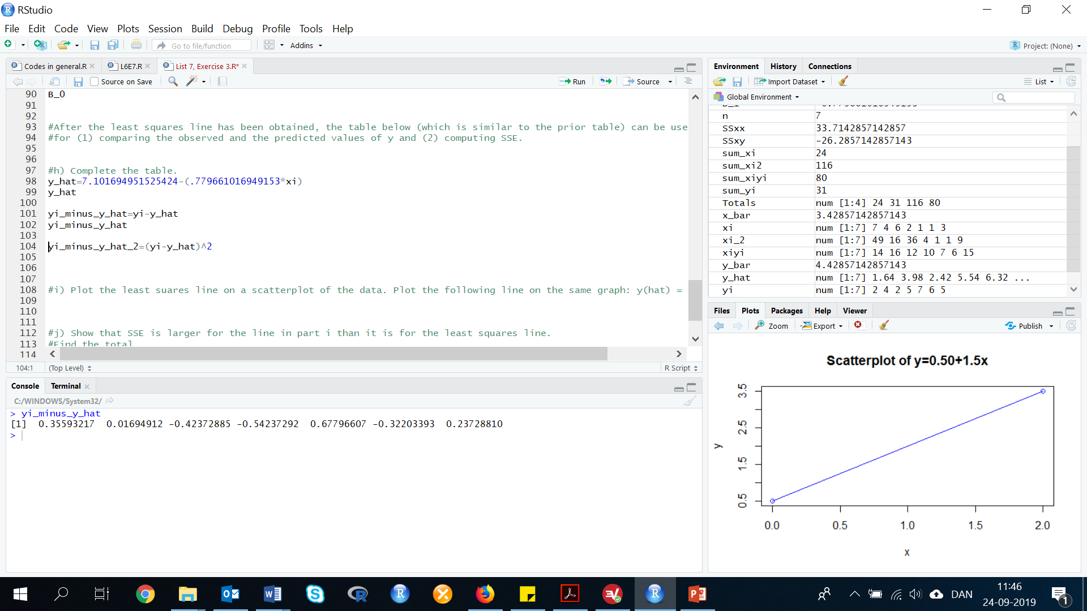

yi_minus_y_hat_2=(yi-y_hat)^2

yi_minus_y_hat_2

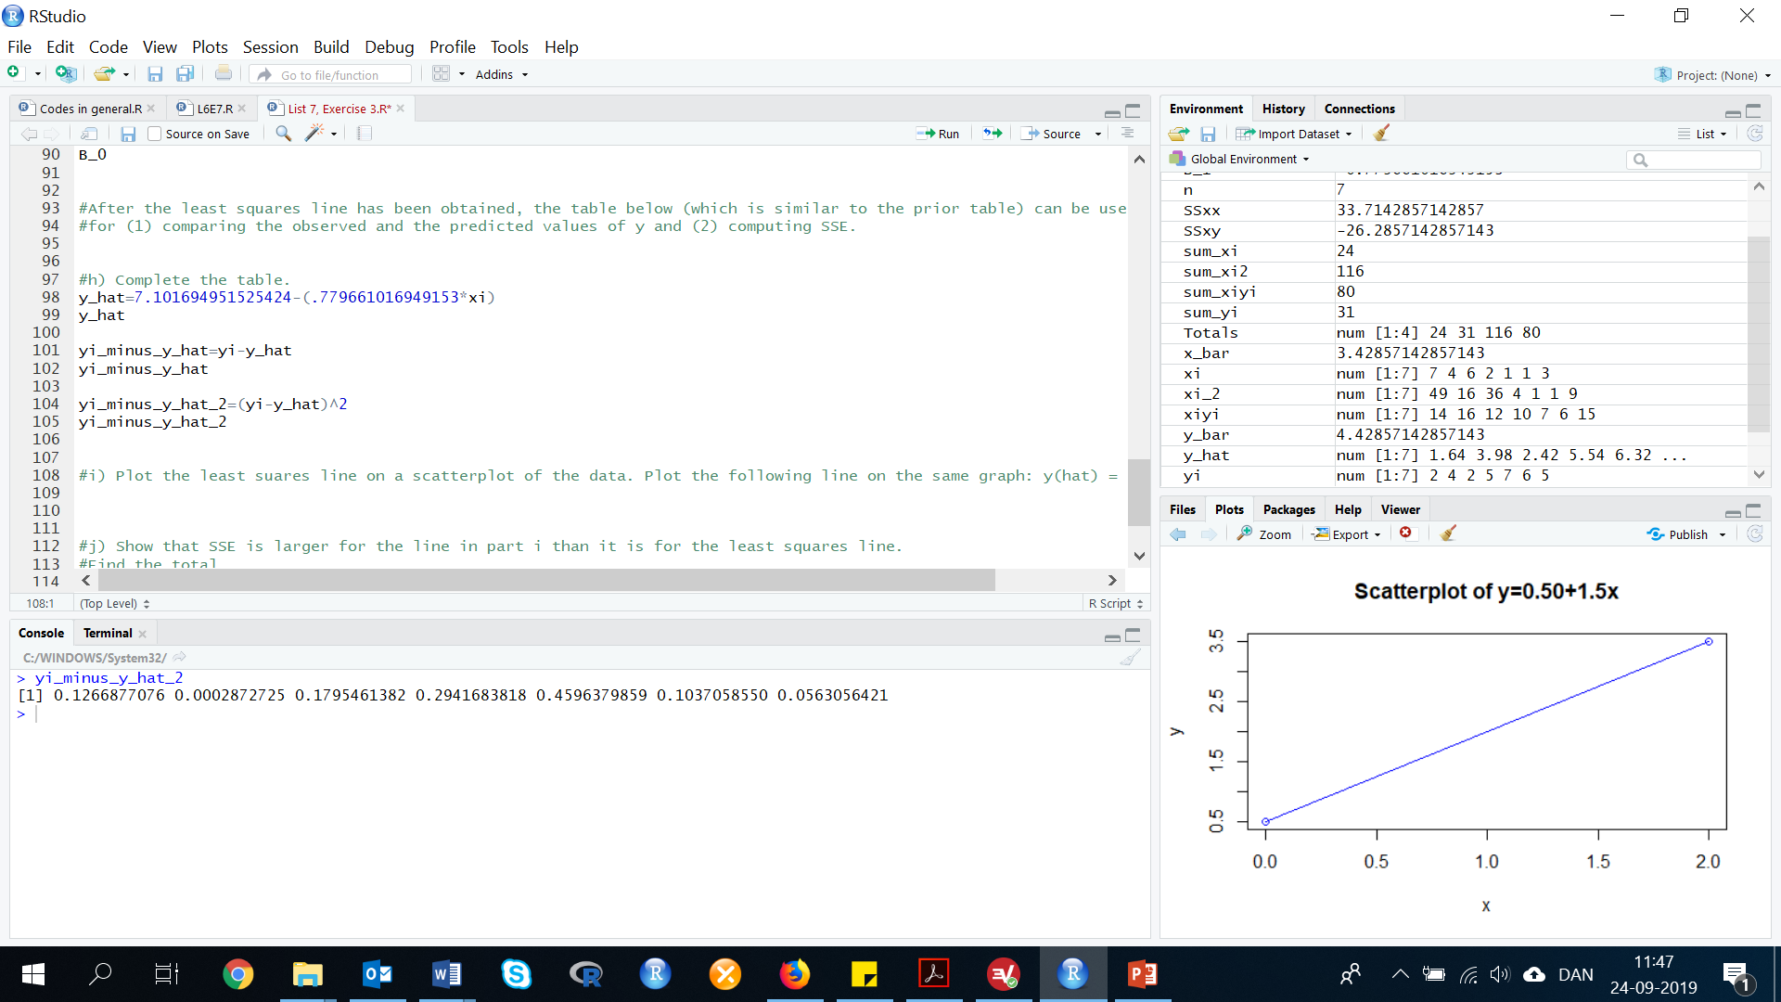

1. **Plot the least squares line on a scatterplot of the data. Plot the following line on the same graph:**

$\hat{y}=$**14 – 2.5 x.**

$\hat{y}$ =7.101694951525424-.779661016949153x

$\hat{y}$ =14-2.5x

Now plot the functions:

plot(xi, yi, main="Scatterplot", col="red")

abline(14, -2.5, col="blue")

lines(xi, fitted(Reg), col="red")

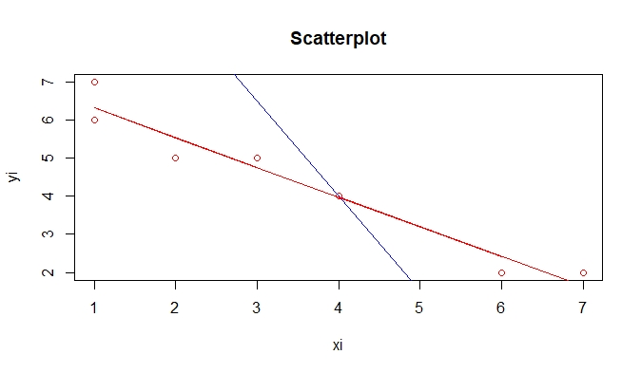

1. **Show that SSE is larger for the line in part i than it is for the least squares line.**

Find the total:

Total of yi-y_hat is found with:

sum_y_minus_y_hat=5.5+0+3+(-4)+(-4.5)+(-5.5)+(-1.5)

sum_y_minus_y_hat_2=(30.25+0+9+16+20.25+30.25+2.25)

SSE=108

**Exercise 4. (20, FEMA). *Public corruption and bad weather*. The Federal Emergency Management Agency (FEMA) provides disaster relief for states impacted by natural disasters (e.g. hurricanes, tornados, floods). DO these bad wheather windfalls lead to public corruption? This was the research question of interest in an article published in the (Journal of Law and Economics (Nov. 2008). Data on y = average annual number of public corruption convictions (per 100,000 residents) and x = average annual FEMA relief (in dollars) per capita for each of the 50 states were used in the investigation.**

First, we need to do as followed:

1. Clean your screen
2. Import data
3. Create variables
4. Run Library(mosaic)

For explanation how to do this look at List 1, Exercise 1.

Clean R Script: rm(list=ls())

Library: library(mosaic)

Import data from Excel: library(readxl)

L7E4 <- read_excel("~/SDC/Quantitative Research Methods Course/Exercises/Dataset/List7/L7E4.xlsx")

View(L7E4)

attach(L7E4)

Create variables: STATE <- STATE

AAFEMA <- AAFEMA

AACC<-AACC

FEMA09_MIL <- FEMA09_MIL

POP10_THOU<- POP10_THOU

PC10yrs <- PC10yrs

FEMA_PERCAP<-FEMA_PERCAP

Convictions_PERCAP <- Convictions_PERCAP

1. **Access the data saved in the file and construct a scatterplot. Do you observe a trend?**

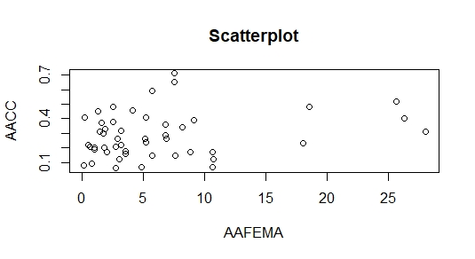plot(AAFEMA, AACC, main="Scatterplot", xlab="AAFEMA", ylab="AACC")

There appears to be a somewhat positive linear relationship between the average annual number of public corruption convictions and the average annual FEMA relief.

1. **Fit the simple linear regression model E(y) = β0 + β1 x to the data and obtain estimates of the intercept and slope.**

In this exercise, we need to make a linear regression model:

lm(formula = y ~ x, data = DATA)

Insert data:

lm(formula = AACC ~ AAFEMA, data = L7E4)

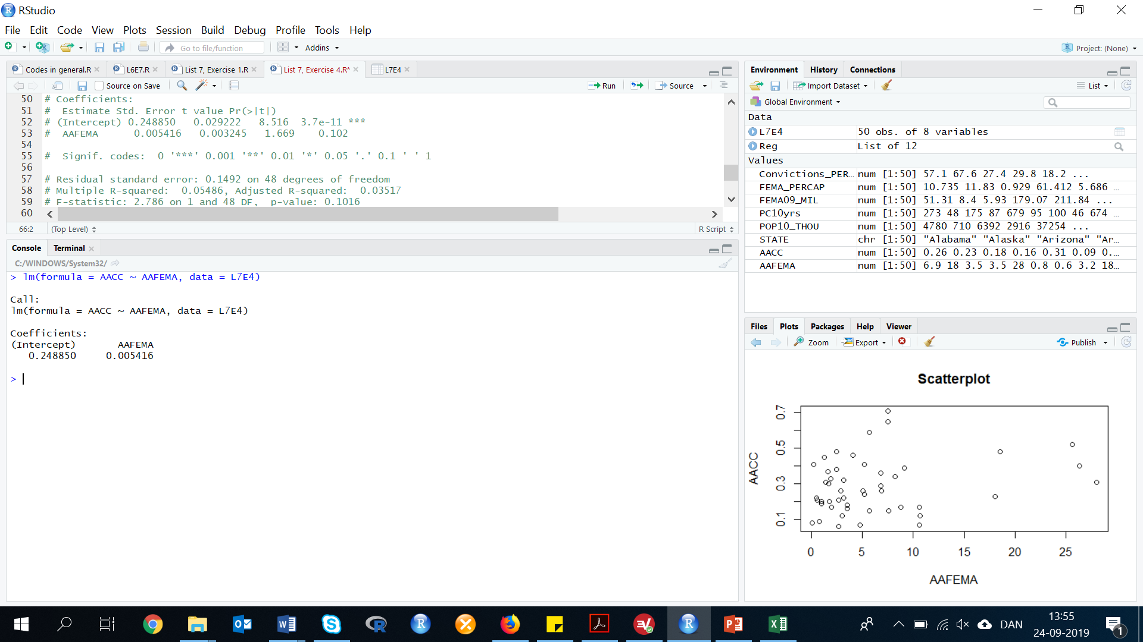

We need to make our regression model into a vector, because we need to work with it. We call the vector ‘Reg’:

Reg <-lm(formula = AACC ~ AAFEMA, data = L7E4)

To get a summary of the regression model, we run the code summary():

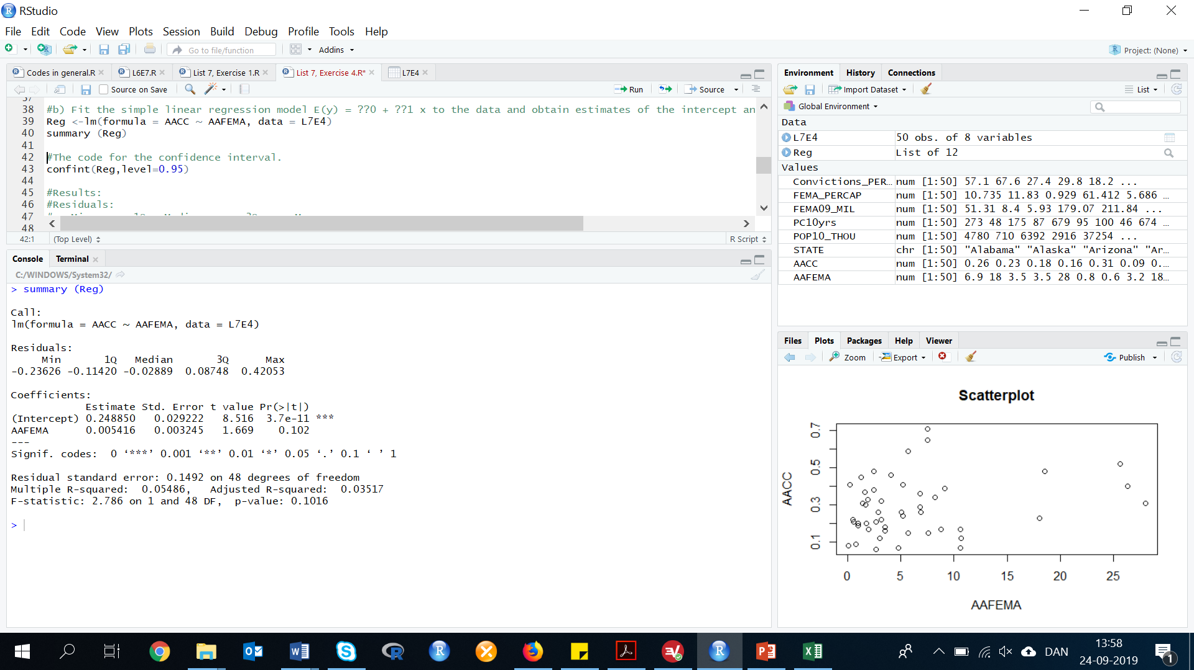summary (Reg)

By looking at this regression you will notice that the p-value for the intercept (Beta 0) is very low (below 1%) or that the t-value for Beta 0 is high. Furthermore, you will notice the three stars (***) just beside the p-value. This indicates, that it is statistically significant, at the 0.001 significance level. But because 0 is not in the observed range of the average annual FEMA relief, beta 0 has no economic meaning.

The slope 0.005 has a p-value above 0.1, which indicates that Beta 1 (the slope) is not significant at the 10%, 5% or 1% level. In order to be statistically significant for example at the 10% level, the p-value should be below 10%. Because it is not significant, the slope has no economical meaning.

The fitted regression model is:

y=0.248850+0.005416

1. **Practically interpret the estimated intercept and estimated slope.**

$${\hat{β}}_{0}=0.248850$$

Since 0 is not in the observed range of the average annual FEMA relief, Beta(0)_hat has no meaning.

**Exercise 5. (25, TOPBUS). *Survey on the top business schools*. Each year, the Wall Street Journal and Harris Interactive track the opinions and summarize the results in the Business School Survey. One of these surveys included rankings of 76 business schools. Survey data for the top 10 business schools are given in the table above. All data are saved in the file.**

First, we need to do as followed:

1. Clean your screen
2. Import data
3. Create variables
4. Run Library(mosaic)

For explanation how to do this look at List 1, Exercise 1.

Clean R Script: rm(list=ls())

Library: library(mosaic)

Import data from Excel: library(readxl)

L7E5 <- read_excel("~/SDC/Quantitative Research Methods Course/Exercises/Dataset/List7/L7E5.xlsx")

View(L7E5)

attach(L7E5)

Create variables: School <- School

Enrollment <- Enrollment

Tuition_Dollar <- Tuition_Dollar

GMAT <- GMAT

JobOffer_Percent <- JobOffer_Percent

Salary_Dollar <- Salary_Dollar

1. **Select one of the variables as the dependent variable, y, and another as the independent variable, x. Use your knowledge of the subject area and common sense to help you select the variables.**

mean(GMAT)

mean(Salary_Dollar)

Results: Mean GMAT = 694.4

Mean Salary = 108028.8

We will select Average Salary as the dependent variable and Mean GMAT as the independent variable.

1. **Fit the simple linear model, E(y) = β0 + β1 x, to the data for all 76 business schools. Interpret the estimates of the slope and y-intercept.**

This exercise can be solved in two different ways:

Method 1: calculating in R

lm(formula = y ~ x, data = DATA)

Reg<-lm(formula = Salary_Dollar ~ GMAT, data = L7E5)

summary (Reg)

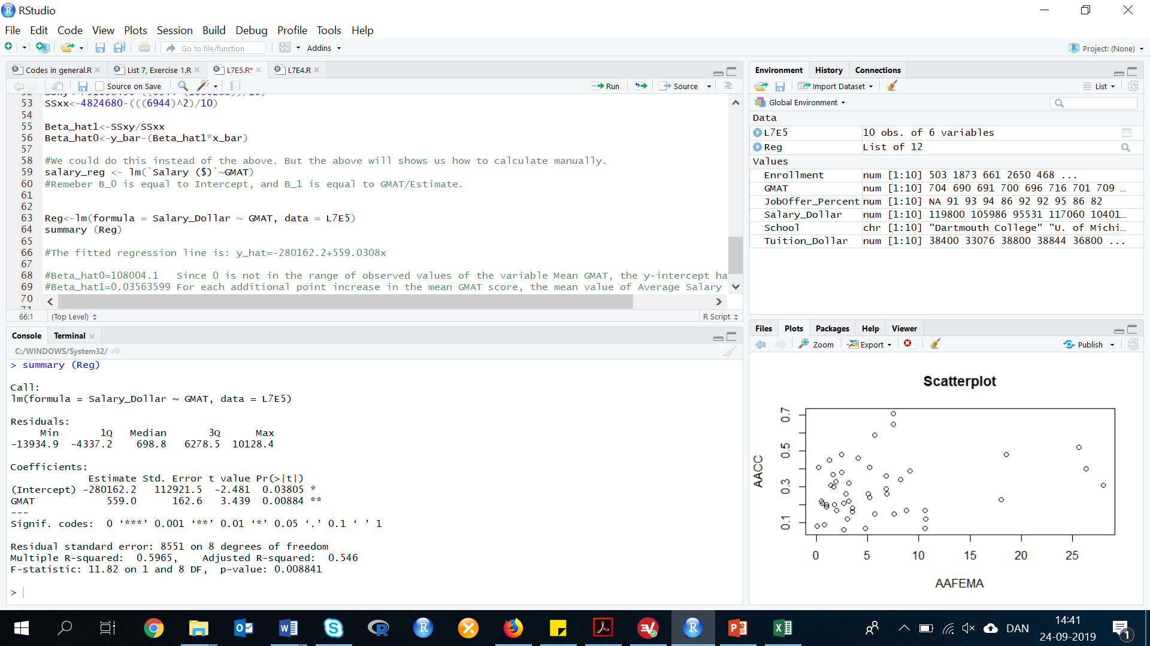

The fitted regression line is:

$\hat{y}=-280,162.2+559.0x$

If we look at the data, we can see that both the B0(*) and B1(**) are statistical significant, as the p-value is very low (below 1).

B0=-280,162.2

Since 0 is not in the range of observed values of the variable Mean GMAT, the y-intercept has no meaning.

B1=559.031

For each additional point increase in the mean GMAT score, the mean value of Average Salary is estimated to increase by $559.031.

Method 2: Manual calculation

Some preliminary calculations are:

Look at List 7, Exercise 3 for further explanation how to calculate the values below.

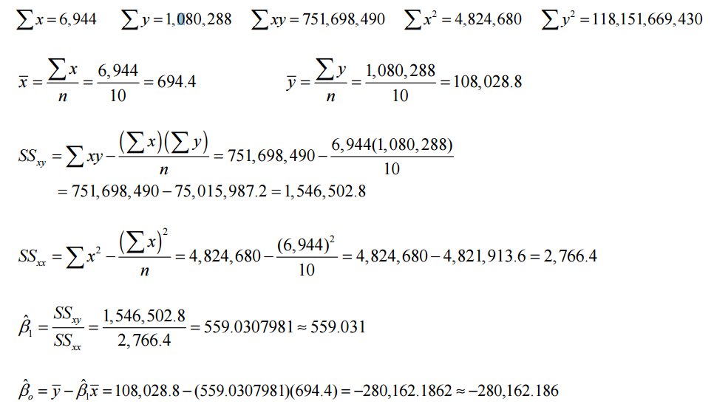

The fitted regression line is:

$\hat{y}=-280,162.2+559.0x$

As we can see the results in both method 1 and 2 are the same.

**11.3 Model Assumptions**

**Exercise 6. (36, FEMA). *Public corruption and bad weather*. Refer to the Journal of Law and Economics (No. 2008) study of the link between Federal Emergency Management Agency (FEMA) disaster relief and public corruption. In exercise 4, you used the data in the file to fit a straight-line model relating a state’s average annual number of public corruption convictions (y) to the state’s average annual FEMA relief (x).**

First, we need to do as followed:

1. Clean your screen
2. Import data
3. Create variables
4. Run Library(mosaic)

For explanation how to do this look at List 1, Exercise 1.

Clean R Script: rm(list=ls())

Library: library(mosaic)

Import data from Excel: library(readxl)

L7E6 <- read_excel("~/SDC/Quantitative Research Methods Course/Exercises/Dataset/List7/L7E6.xlsx")

View(L7E6)

attach(L7E6)

Create variables: STATE <- STATE

AAFEMA <- AAFEMA

AACC<-AACC

FEMA09_MIL <- FEMA09_MIL

POP10_THOU<- POP10_THOU

PC10yrs <- PC10yrs

FEMA_PERCAP<-FEMA_PERCAP

Convictions_PERCAP <- Convictions_PERCAP

1. **Estimate σ2, the variance of the random error term in the model.**

anova(lm(AACC ~ AAFEMA, L7E6))

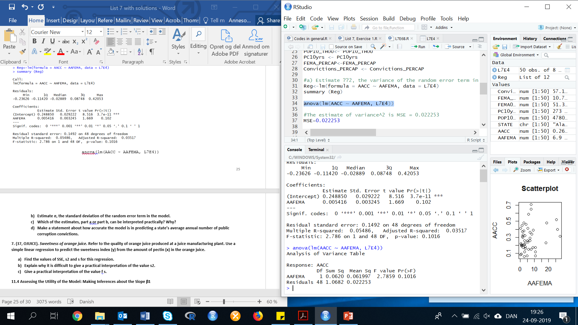

The estimate of variance^2 is MSE = 0.022253.

MSE = 0.022253

1. **Estimate σ, the standard deviation of the random error term in the model.**

sqrt(MSE)

σ = 0.1491744

1. **Which of the estimates, part a or part b, can be interpreted practically? Why?**

The standard deviation in part b can be interpreted practically. The standard deviation is measured in the same units as the data. The variance is measured in square units and is very difficult to interpret.

1. **Make a statement about how accurate the model is in predicting a state’s average annual number of public corruption convictions.**

summary(AACC)

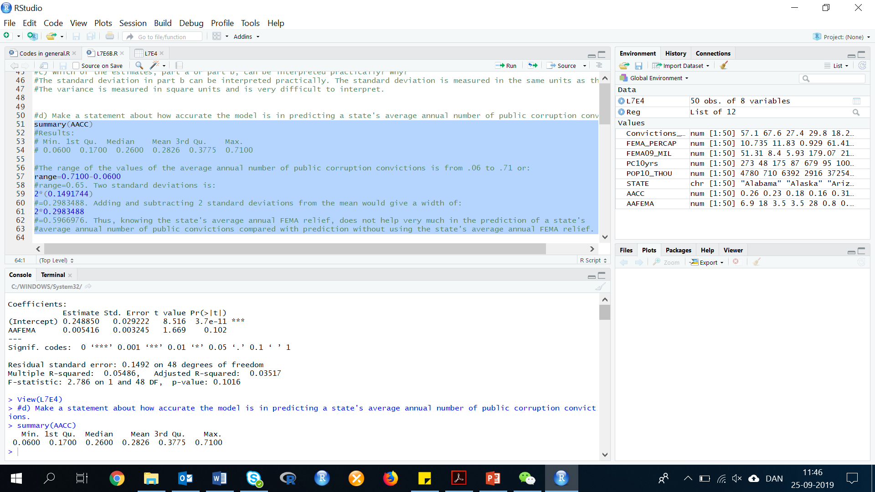

The range of the values of the average annual number of public corruption convictions is from .06 to .71 or:

range=0.7100-0.0600

range=0.65.

Two standard deviations is:

2*σ

2*(0.1491744)

Result: 0.2983488.

Adding and subtracting 2 standard deviations from the mean would give a width of:

2*0.2983488

Result: 0.5966976.

Thus, knowing the state's average annual FEMA relief, does not help very much in the prediction of a state's average annual number of public convictions compared with prediction without using the state's average annual FEMA relief.

**Exercise 7. (37, OJUICE). *Sweetness of orange juice*. Refer to the quality of orange juice produced at a juice manufacturing plant. Use a simple linear regression to predict the sweetness index (y) from the amount of pectin (x) in the orange juice.**

First, we need to do as followed:

1. Clean your screen
2. Import data
3. Create variables
4. Run Library(mosaic)

For explanation how to do this look at List 1, Exercise 1.

Clean R Script: rm(list=ls())

Library: library(mosaic)

Import data from Excel: library(readxl)

L7E7 <- read_excel("~/SDC/Quantitative Research Methods Course/Exercises/Dataset/List7/L7E7.xlsx")

View(L7E7)

attach(L7E7)

Create variables: Run <- Run

Sweetness_Index <- Sweetness_Index

Pectin_ppm <- Pectin_ppm

SSE is the sum of squares for error. The formula for SSE= SSyy-b1SSxy, s= sample standard deviation s^2= sample variance SSE is the sum of squares for error. The formula for SSE= SSyy-b1SSxy s= sample standard deviation s^2= sample variance

To calculate manually, you must first calculate: Sx, Sy, Sx^2, Sxy, SSxy, SSxx, b1, Syy, SSyy:

Calculate Sx^2, Sy^2 and Sxy:

Sx^2 is the sum of each x value squared

Sy^2 is the sum of each y value squared

Sxy is the sum of each x times its corresponding y value

Sweetness_index is y because it is dependent on the Pectin which is x.

1. **Find the values of SSE, s2 and s for this regression.**

Method 1:

Use the anova() code, to calculate the SSE, s2 and s for this regression:

anova(lm(y~x, DATA)

Insert data:

anova(lm(Sweetness_Index~Pectin_ppm, L7E7))

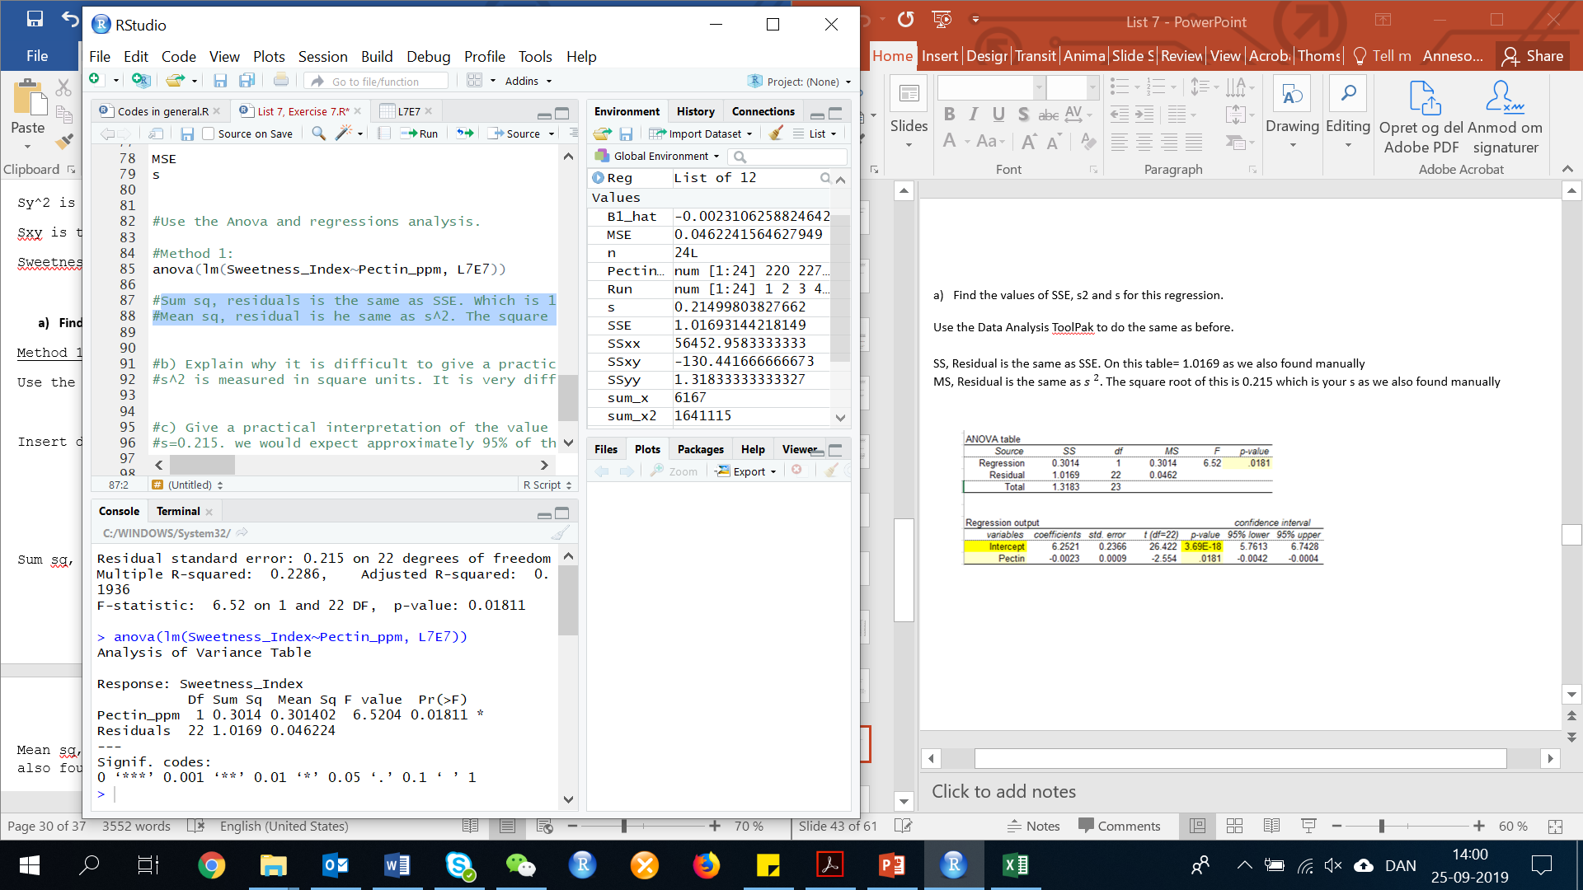

If we look at:

Sum sq, residuals is the same as SSE. The SSE = 1.0169, we will find this value below manually (method 2).

Mean sq, residual is the same as s^2.

The square root of this (s) is:

sqrt(0.046224)

sqrt=0.2149977

We also will also find this value manually below.

Method 2:

First, n=24.

Calculation of Sx and Sy:

sum_x<-sum(Pectin_ppm)

sum_y<-sum(Sweetness_Index)

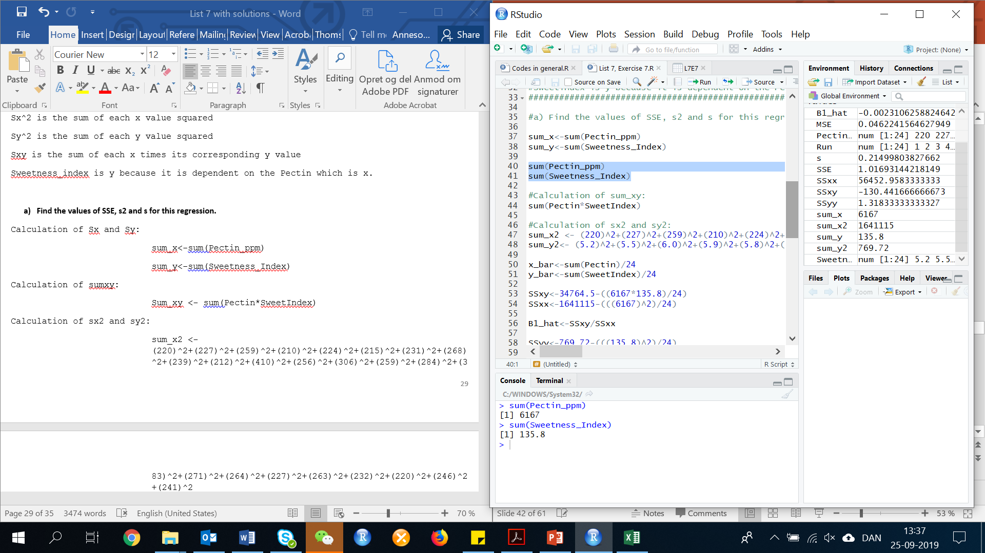

Calculation of sumxy:

sum_xy <- sum(Pectin_ppm*Sweetness_Index)

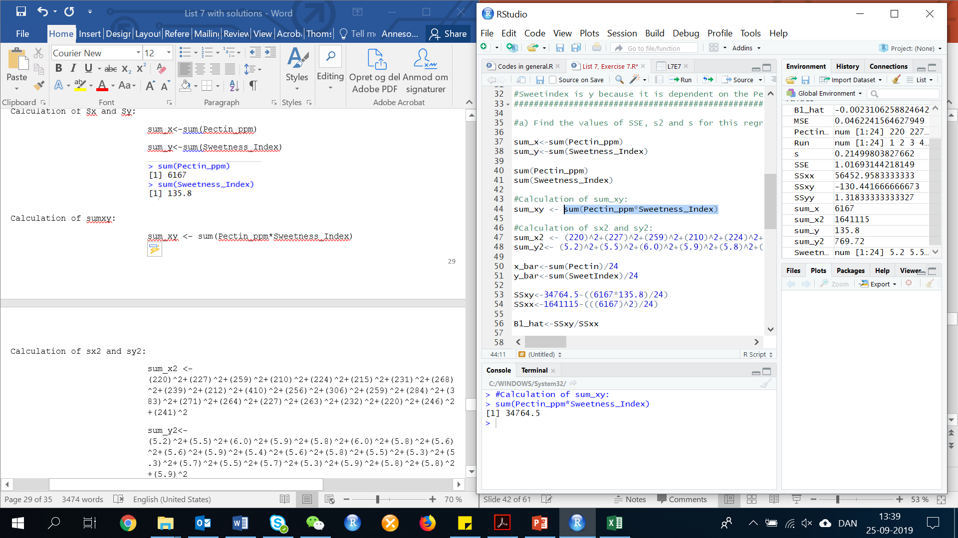

Calculation of sx2 and sy2:

sum_x2 <- (220)^2+(227)^2+(259)^2+(210)^2+(224)^2+(215)^2+(231)^2+(268)^2+(239)^2+(212)^2+(410)^2+(256)^2+(306)^2+(259)^2+(284)^2+(383)^2+(271)^2+(264)^2+(227)^2+(263)^2+(232)^2+(220)^2+(246)^2+(241)^2

sum_y2<- (5.2)^2+(5.5)^2+(6.0)^2+(5.9)^2+(5.8)^2+(6.0)^2+(5.8)^2+(5.6)^2+(5.6)^2+(5.9)^2+(5.4)^2+(5.6)^2+(5.8)^2+(5.5)^2+(5.3)^2+(5.3)^2+(5.7)^2+(5.5)^2+(5.7)^2+(5.3)^2+(5.9)^2+(5.8)^2+(5.8)^2+(5.9)^2

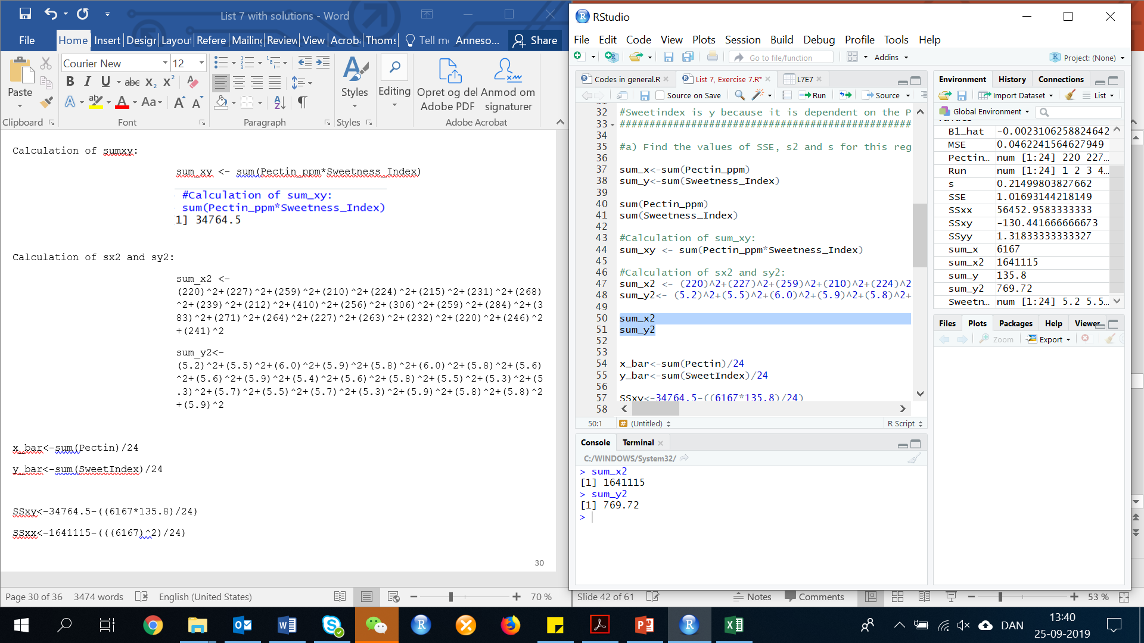

Calculation:

SSxy <- sum_xy-((sum_x*sum_y)/n)

SSxx <- sum_x2-(((sum_x)^2)/n)

SSyy <- sum_y2-(((sum_y)^2)/n)

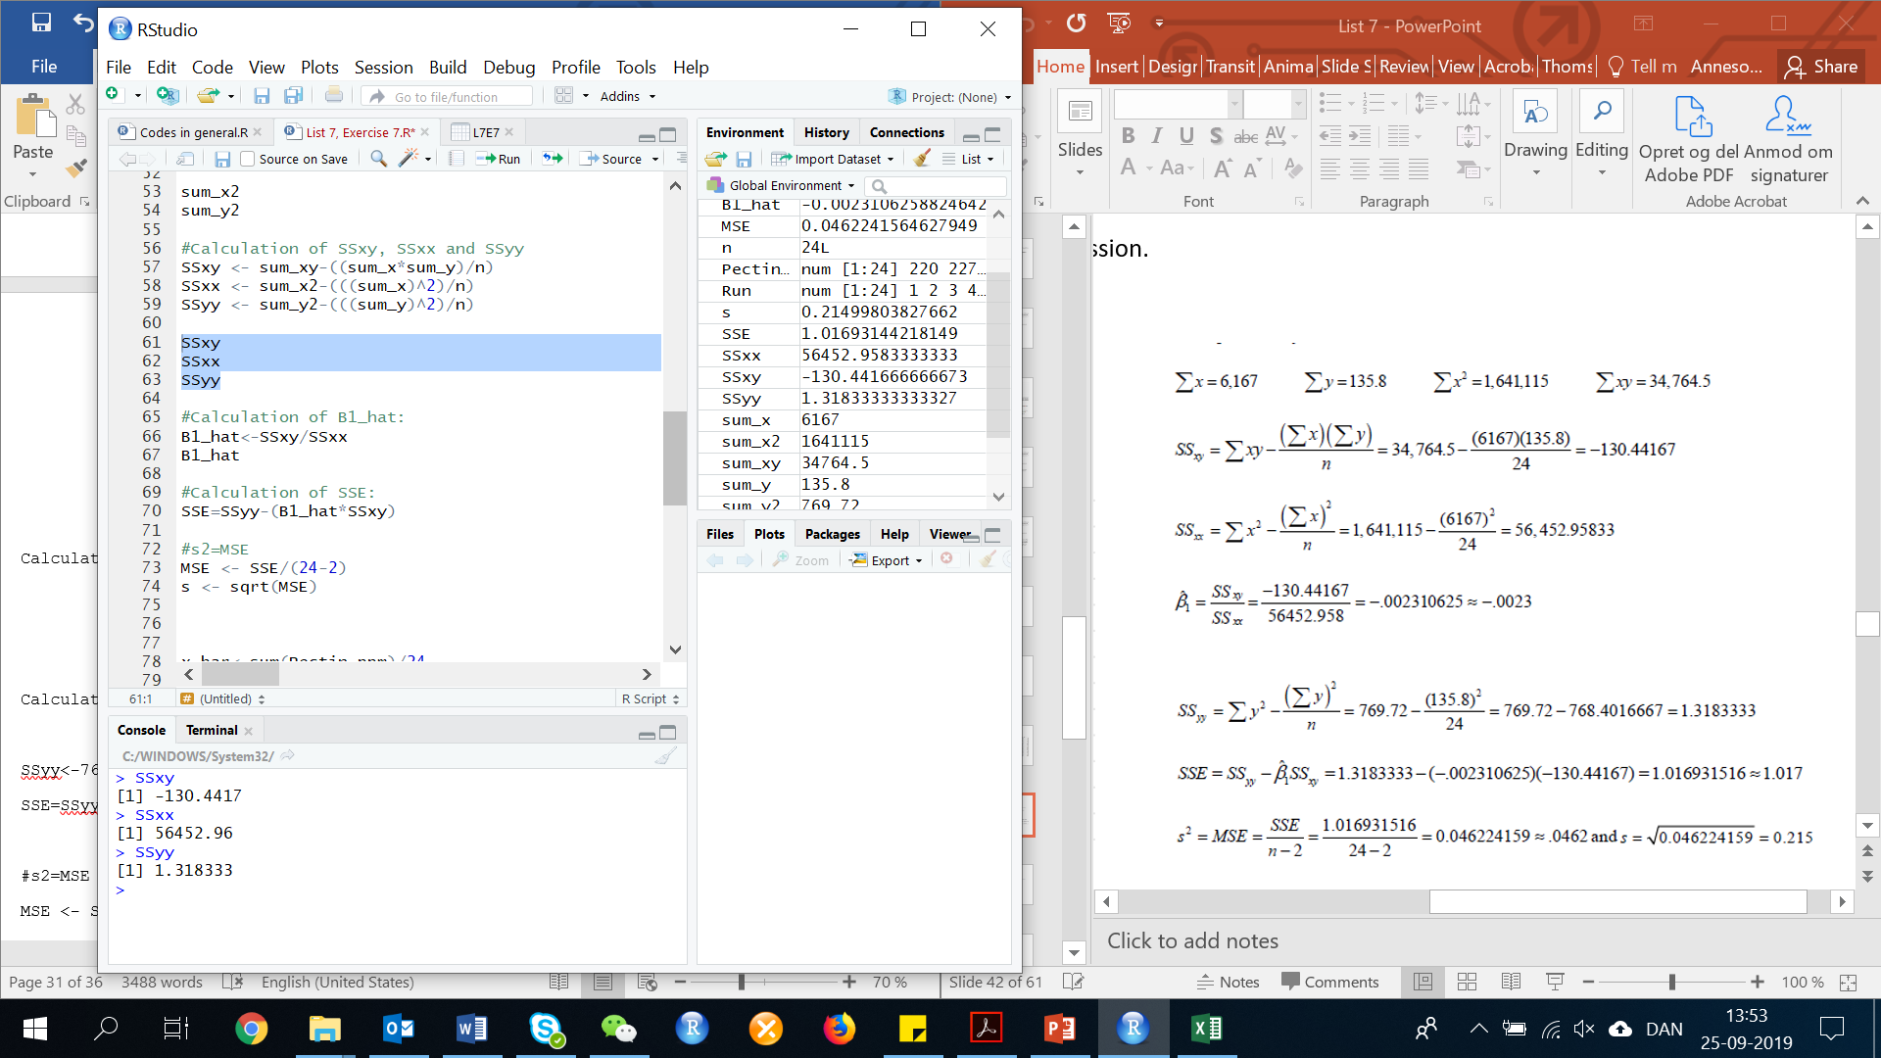

Calculation of ${\hat{β}}_{1}:$

B1_hat<-SSxy/SSxx

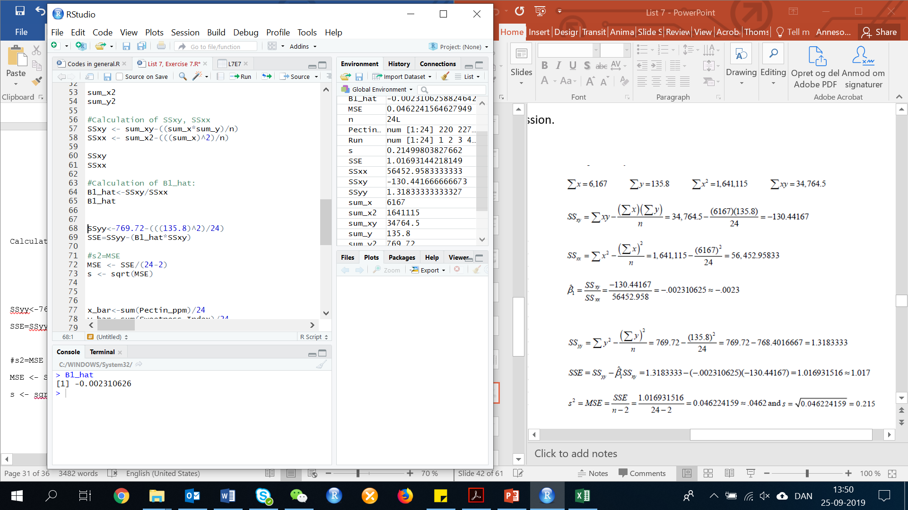

Calculation of SSE:

SSE <- SSyy-(B1_hat*SSxy)

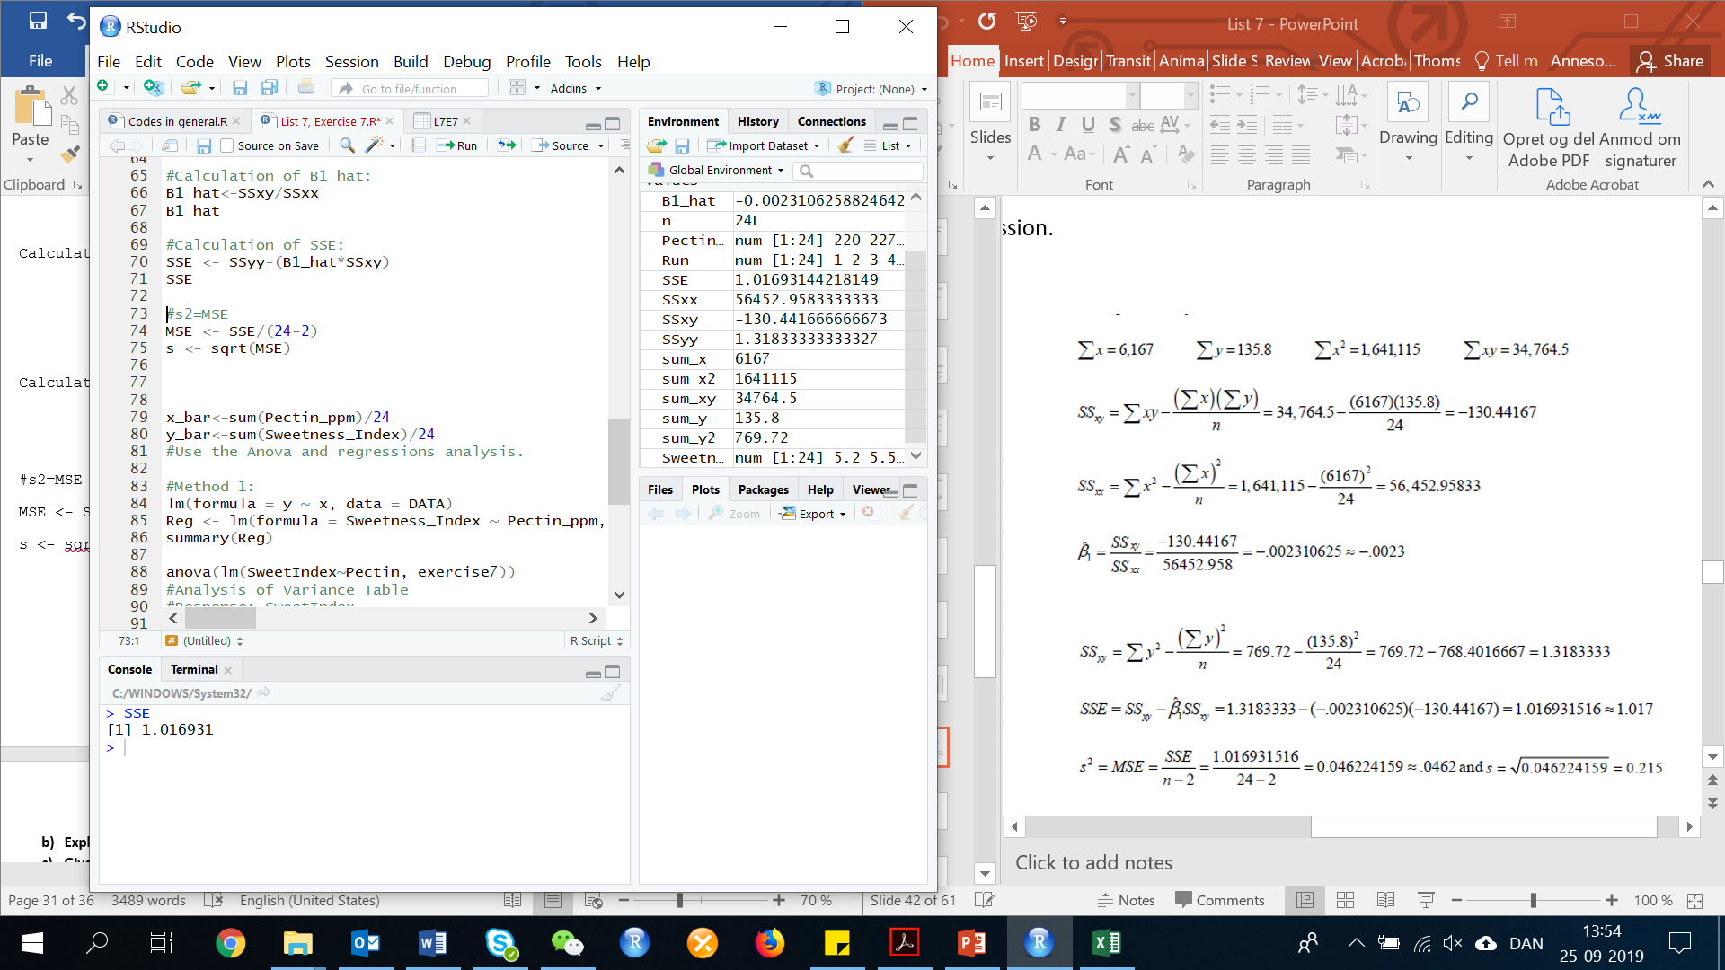

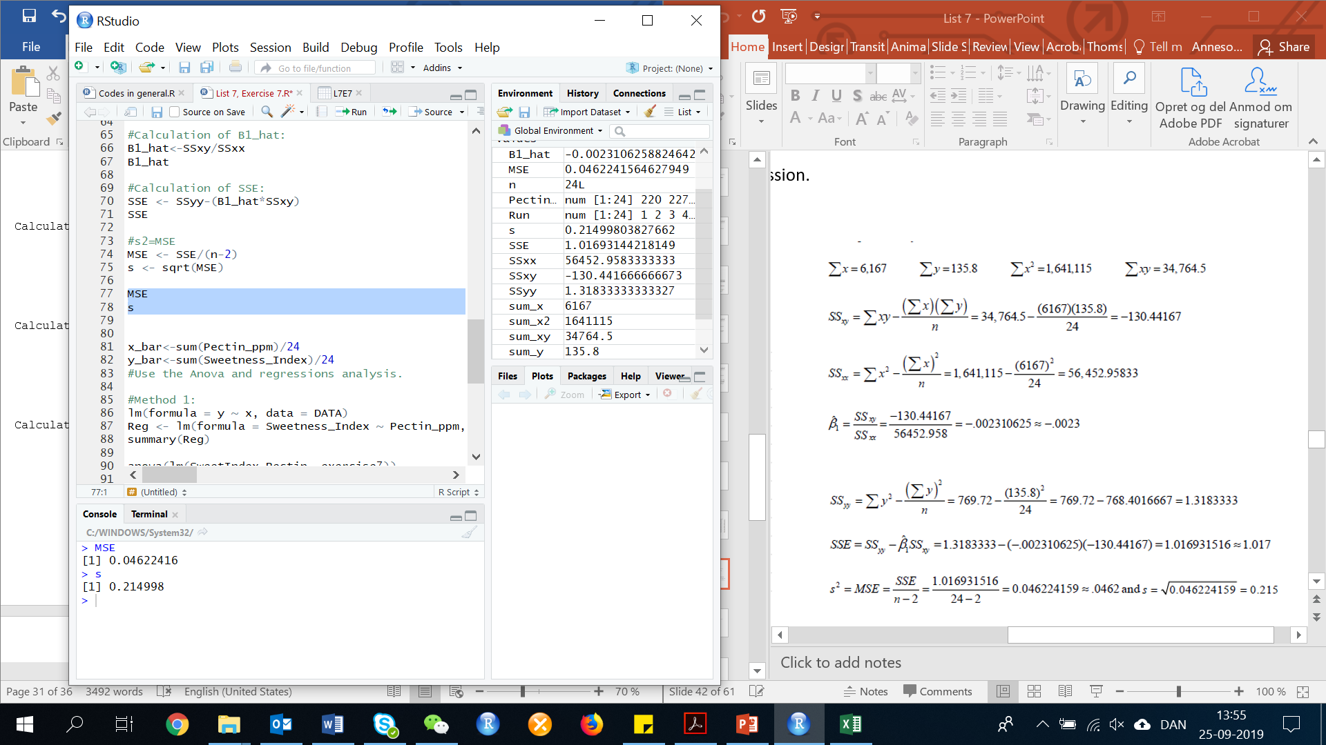Calculation of s:

s2=MSE

MSE <- SSE/(n-2)

s <- sqrt(MSE)

1. **Explain why it is difficult to give a practical interpretation of the value s2.**

S2 is measured in square units. It is very difficult to explain something measured in square units.

1. **Give a practical interpretation of the value f s.**

s=0.2149977. we would expect approximately 95% of the observed values of y (Sweetness index) to fall within 2s or:

2*s

2*0.2149977

Result: 0.4299954 units of their least squares predicted values.

**11.4 Assessing the Utility of the Model: Making Inferences about the Slope β1**

**Exercise 8. (51, BDAYS). *Software millionaires and birthdays*. Refer to the study of whether birth decade can predict the number of software millionaires born in the decade. The data are reproduced in the table below:**

|  |  |  |  |
| --- | --- | --- | --- |
| **Decade** | **Total US births (millions)** | **N. of Software Millionaires Birthdays** | **N. of CEO Birthdays (in a random sample of 70 companies from the Fortune 500 list)** |
| **1920** | **28582** | **3** | **2** |
| **1930** | **24374** | **1** | **2** |
| **1940** | **31666** | **10** | **23** |
| **1950** | **40530** | **14** | **38** |
| **1960** | **38808** | **7** | **9** |
| **1970** | **33309** | **4** | **0** |

First, we need to do as followed:

1. Clean your screen
2. Import data
3. Create variables
4. Run Library(mosaic)

For explanation how to do this look at List 1, Exercise 1.

Clean R Script: rm(list=ls())

Library: library(mosaic)

Import data from Excel: library(readxl)

L7E8 <- read_excel("~/SDC/Quantitative Research Methods Course/Exercises/Dataset/List7/L7E8.xlsx")

View(L7E8)

attach(L7E8)

Create variables: DECADE <- DECADE

USBIRTHS <- USBIRTHS

SWBDAYS <- SWBDAYS

CEOBDAYS <- CEOBDAYS

1. **Construct a 95% confidence interval for the slope of the model, E(y) = β0 + β1 x, where x = total number of US births and y = number of software millionaire birthdays. Give a practical interpretation of the interval assuming that .**

Note: the standard error is when the sample mean deviates from the actual mean of the population.

There is two ways to solve this:

Method 1: In R

A simple way to answer the question:

Reg<-lm(formula = SWBDAYS~USBIRTHS, data = L7E8)

summary (Reg)

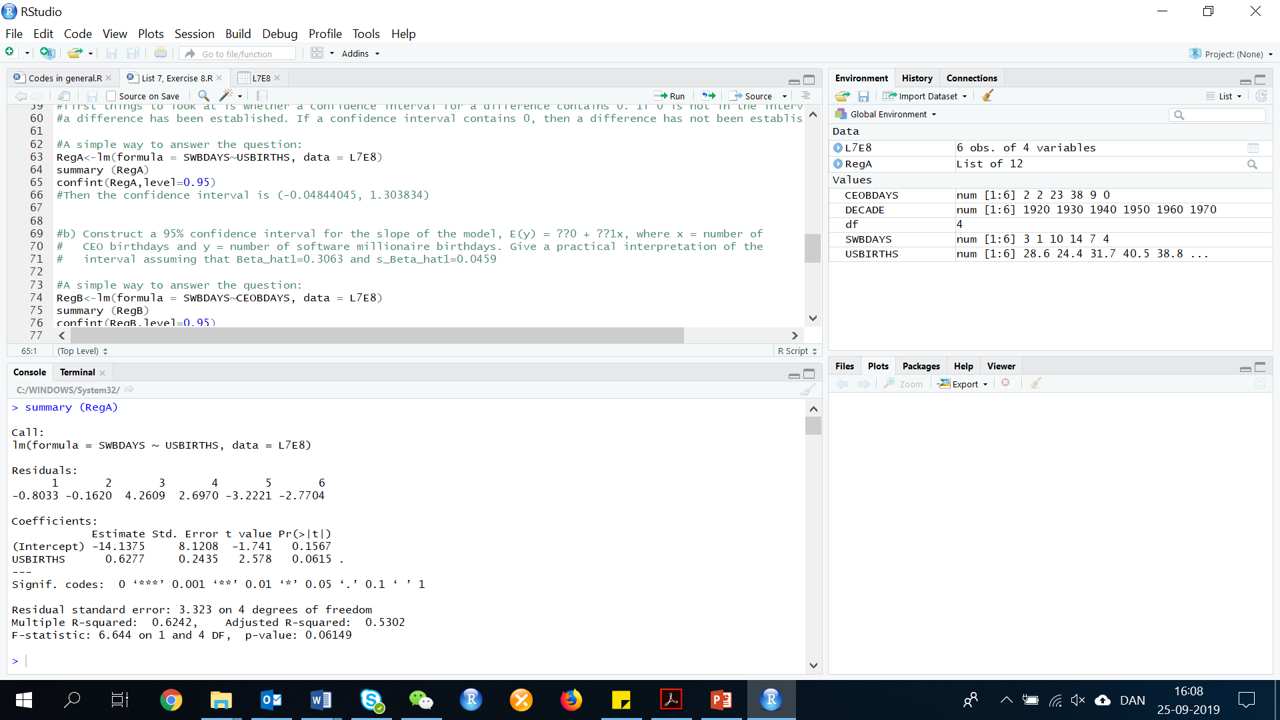

confint(Reg,level=0.95)

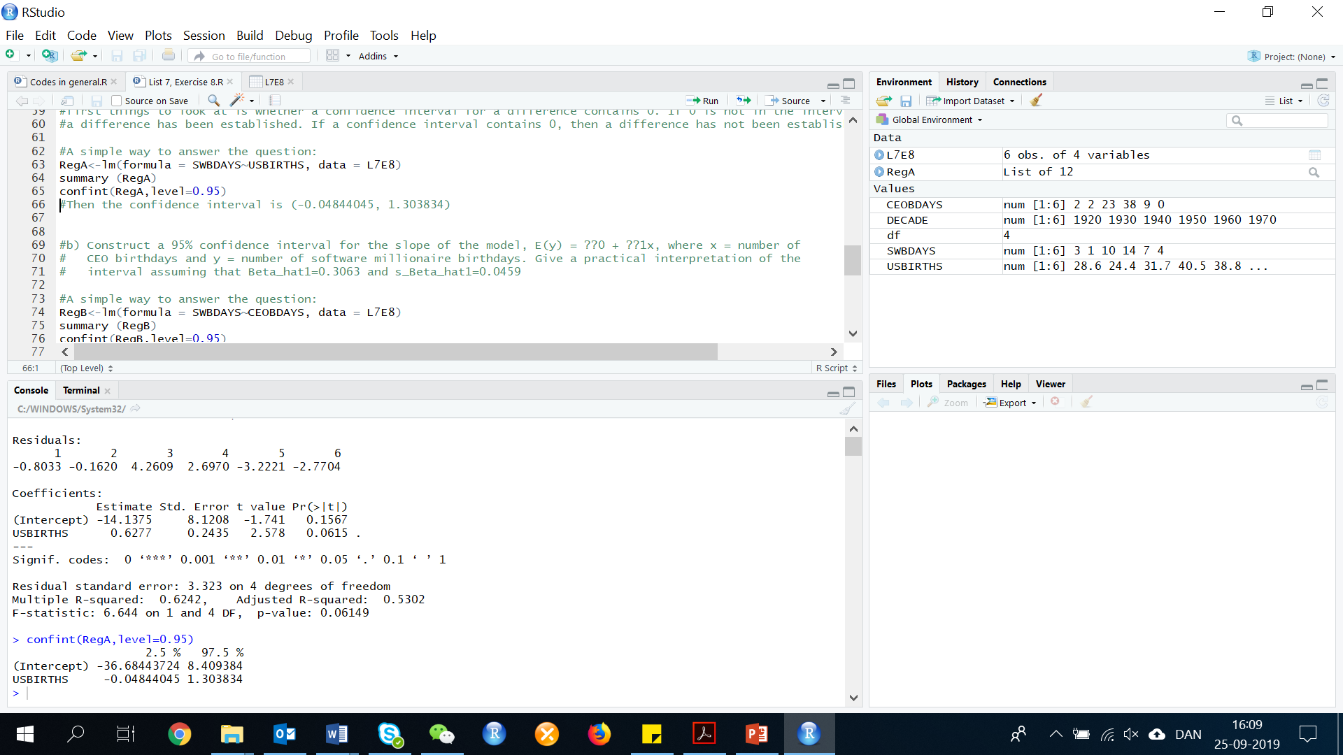

Then the confidence interval is (-0.04844045, 1.303834)

Method 2: Manual calculation

First, make a regression analysis, to get the value of B1

Reg <- lm(formula = SWBDAYS ~ USBIRTHS, data = L7E8)

summary(Reg)

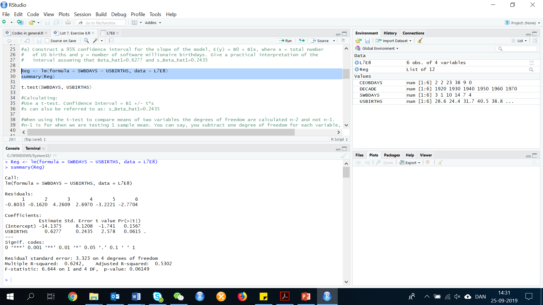

B1 = 0.6277 and sB1 = 0.2435. With these values, we can calculate the confident coefficient. For confidence coefficient 0.95, α=0.05 and α/2=0.05/2=0.025. We need the degrees of freedom, before we can look in the t-table.

When using the t-test to compare means of two variables the degrees of freedom are calculated n-2 and not n-1. n-1 is for when we are testing 1 sample mean. You can say, you subtract one degree of freedom for each variable, and since there are 2 variables, the degrees of freedom are n-2. You have 6 different decades.

df=n-2

df=n-2=4

By looking in the t-table, we can see that t0.025=2.776. Now we can calculate the confidence interval, plug in your b1, t, and s:

B1 +/- t*s

0.6277+(2.776*(0.2435))= 1.303656

0.6277-(2.776*(0.2435))= -0.048256

Confidence interval = (-0.048256, 1.303656)

We are 95% confident that for each additional one million US births, the mean number of software millionaire birthdays will change from =0.0483 to 1.3037. Since 0 is in this interval, there is no evidence of a linear relationship between total US births and the number of software millionaire birthdays.

If a confidence interval for a mean difference includes 0 it means that the data are consistent with a population mean difference of 0. If the difference is 0, the population means are equal.

If the confidence interval for a difference does not include 0, the data are not consistent with equal population means. Therefore, one of the first things to look at is whether a confidence interval for a difference contains 0. If 0 is not in the interval, a difference has been established. If a confidence interval contains 0, then a difference has not been established.

1. **Construct a 95% confidence interval for the slope of the model, E(y) = β0 + β1 x, where x = number of CEO birthdays and y = number of software millionaire birthdays. Give a practical interpretation of the interval assuming that .**

As in the exercise above, there is two ways to solve this. However, we will only look at the way to solve with R. If you would like to do it manually, then look at List 7, Exercise 8, part a.

RegB<-lm(formula = SWBDAYS~CEOBDAYS, data = L7E8)

summary (RegB)

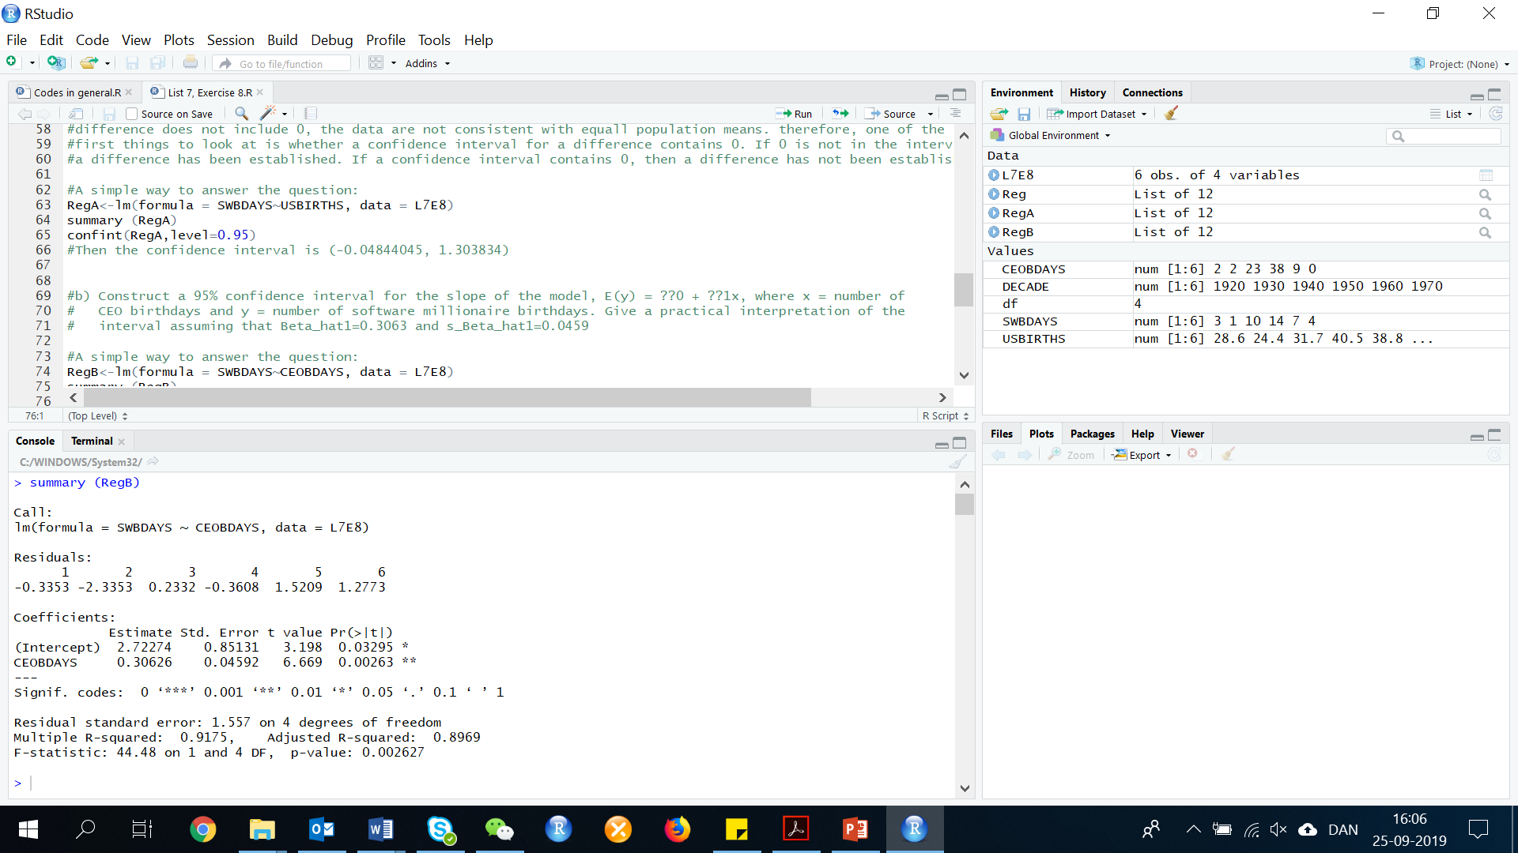

confint(RegB,level=0.95)

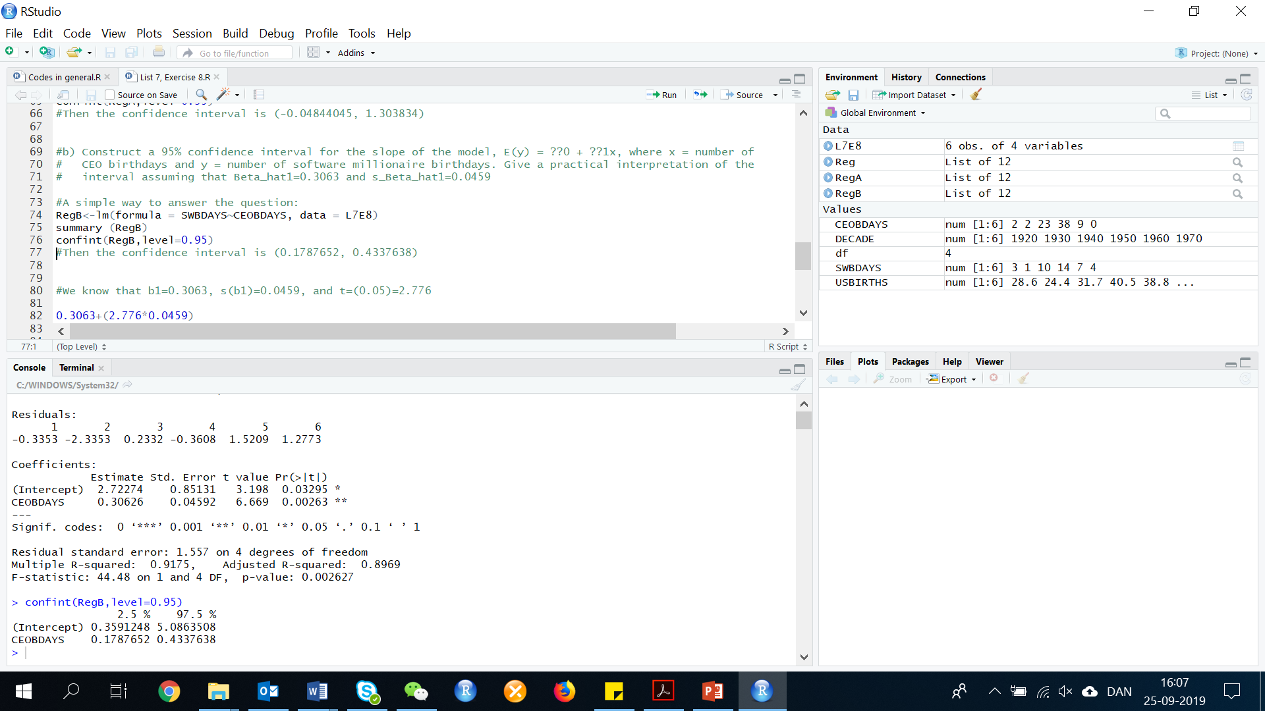

Then the confidence interval is (0.1787652, 0.4337638)

1. **Can you conclude that number of software millionaires born in a decade is linearly related to total number of people born in the USA? Number of CEOs born in the decade?**

No, you can’t conclude that the number of software millionaires born in a decade is linearly related to the number of people born in the US, because 0 is contained in the 95% confidence interval for Beta 1.

Yes, you can conclude that the number of software millionaires born in a decade is linearly related to the number of CEO's born in a decade because 0 is not contained in the 95% confidence interval for B1.

**Exercise 9. (52). *Beauty and electoral success*. Are good looks an advantage when running for political office? This was the question of interest in an article published in the Journal of Public Economics (Feb. 2010). The researchers focused on a sample of 641 nonincumbent candidates for political office in Finland. Photos of each candidate were evaluated by non-Finnish subjects; each evaluator assigned a beauty rating – measured on a scale of 1 (lowest rating) to 5 (highest rating) – to each candidate. The beauty ratings for each candidate were averaged, then the average was divided by the standard deviation for all candidates to yield a beauty index for each candidate. (Note: A 1-unit increase in the index represents a 1-standard-deviation increase in the beauty rating.) The relative success (measured as a percentage of votes obtained) of each candidate was used as the dependent variable (y) in a regression analysis. One of the independent variables in the model was beauty index (x).**

1. **Write the equation of a simple linear regression relating y to x.**

The simple linear regression model is:

$$E\left(y\right)=β_{0}+β_{1}x$$

1. **Does the intercept of the equation (part a) have a practical interpretation? Explain.**

No, the y-intercept will have no practical meaning. The value of x (beauty index) is measured on a scale from 1 to 5, averaged,

#and then divided by the standard deviation. These values will always be greater than 0. Thus, 0 will not be in the observed range for x.

1. **The article reported the estimated slope of the equation (part a) as 22.91. Give a practical interpretation of this value.**

The slope is B(1). For each unit increase in the beauty index, the mean percentage of votes obtained is estimated to increase by 22.91.

1. **The standard error of the slope estimate was reported as 3.73. Use this information and the estimate from part c to conduct a test for a positive slope α = 0.01. Give the appropriate conclusion in the words of the problem.**

To determine if the slope of the lines is positive, we test:

$$H_{0}:β_{1}=0$$

$$H_{a}:β_{1}>0$$

Use the t-test. The formula for the t-statistic can also be written like this. Remember, SE is the standard error of the slope:

$$t_{s}=\frac{β_{1}}{{SE}_{β_{1}}}$$

t=22.91/3.73

t= 6.142091

The rejection region requires, alpha=0.01, in the upper tail of the t-distribution with

df=n-2

df=641-2

From the table t, we find that t with an alpha at 0.01, t(0.01)=2.326. Therefore, the rejection region is t>2.326.

Since the observed value of the test statistic falls in the rejection region (t=6.142 > 2.326). H0 is rejected. There is sufficient evidence to indicate that there is a positive relationship between beauty index and relative success of political candidates at alpha=0.01.

**11.5 The Coefficients of Correlation and Determination**

**Exercise 10. (69, BDAYS). *Software milionaires and birthdays*. Refer to the study of the seemingly disproportionate number of software millionaires born around the year of 1955. The data are reproduced in the table below:**

|  |  |  |  |
| --- | --- | --- | --- |
| **Decade** | **Total US births (millions)** | **N. of Software Millionaires Birthdays** | **N. of CEO Birthdays (in a random sample of 70 companies from the Fortune 500 list)** |
| **1920** | **28582** | **3** | **2** |
| **1930** | **24374** | **1** | **2** |
| **1940** | **31666** | **10** | **23** |
| **1950** | **40530** | **14** | **38** |
| **1960** | **38808** | **7** | **9** |
| **1970** | **33309** | **4** | **0** |

First, we need to do as followed:

1. Clean your screen
2. Import data
3. Create variables
4. Run Library(mosaic)

For explanation how to do this look at List 1, Exercise 1.

Clean R Script: rm(list=ls())

Library: library(mosaic)

Import data from Excel: library(readxl)

L7E10 <- read_excel("~/SDC/Quantitative Research Methods Course/Exercises/Dataset/List7/L7E10.xlsx")

View(L7E10)

attach(L7E10)

Create variables: DECADE <- DECADE

USBIRTHS <- USBIRTHS

SWBDAYS <- SWBDAYS

CEOBDAYS <- CEOBDAYS

1. **Find the coefficient of determination for the simple linear regression model relating number (y) of software millionaire birthdays in a decade to total number (x) of US births. Interpret the result.**

First we need to make the regression:

Reg<-lm(formula = SWBDAYS~USBIRTHS, data = L7E10)

summary (Reg)

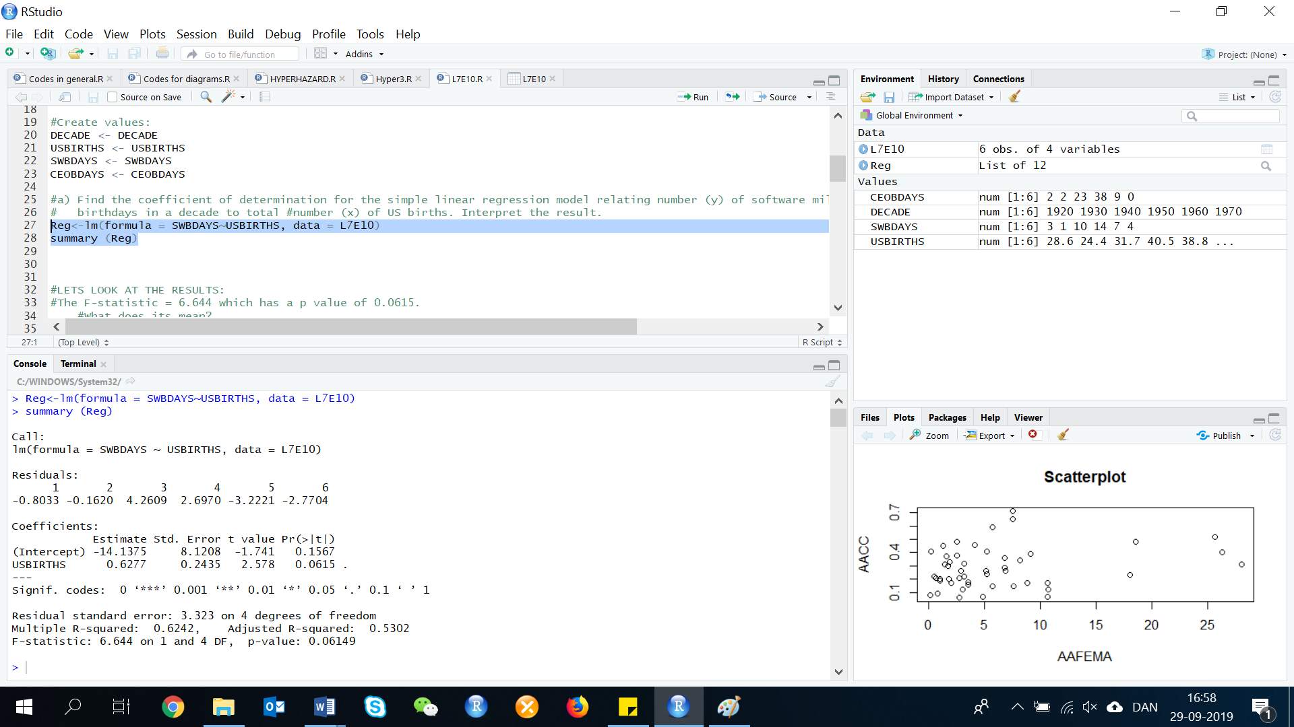

LETS LOOK AT THE RESULTS:

The F-statistic = 6.644 which has a p value of 0.0615. It has a dot right next to it, this implies that this model is statistically significant at the 10% significance level. So US Births explain the number of software millionaires births in 62%

We have a Beta(0) at -14.375, which is the estimate and intercept. And a t=-1.74 with a p-value of 0.1567, which is far above 1%, 5% and 10% of significance. This means that this coefficient is not significant.

We also got Beta(1) at 0.6277, which is the estimate and USBIRTHS, and a t-test with a t-statistics of 2.578 and p-value of 0.0615 (6.15%). This means that this coefficient is significant at the 10% significance level. For every million US births, 0.6277 software millionaires are born.

The simple linear regression model is:

E(y)=-14.375+0.6277x

The R^2 = 0.6242, as given by the problem. R^2=62.4 % of the total sample variability around the sample mean number of software millionaire birthdays is explained by the linear relationship between number of software millionaire birthdays and the total number of US births.

1. **Find the coefficient of determination for the simple linear regression model relating number (y) of software millionaires birthdays in a decade to number (x) of CEO birthdays. Interpret the result.**

Reg<-lm(formula = SWBDAYS~CEOBDAYS, data = L7E10)

summary (Reg)

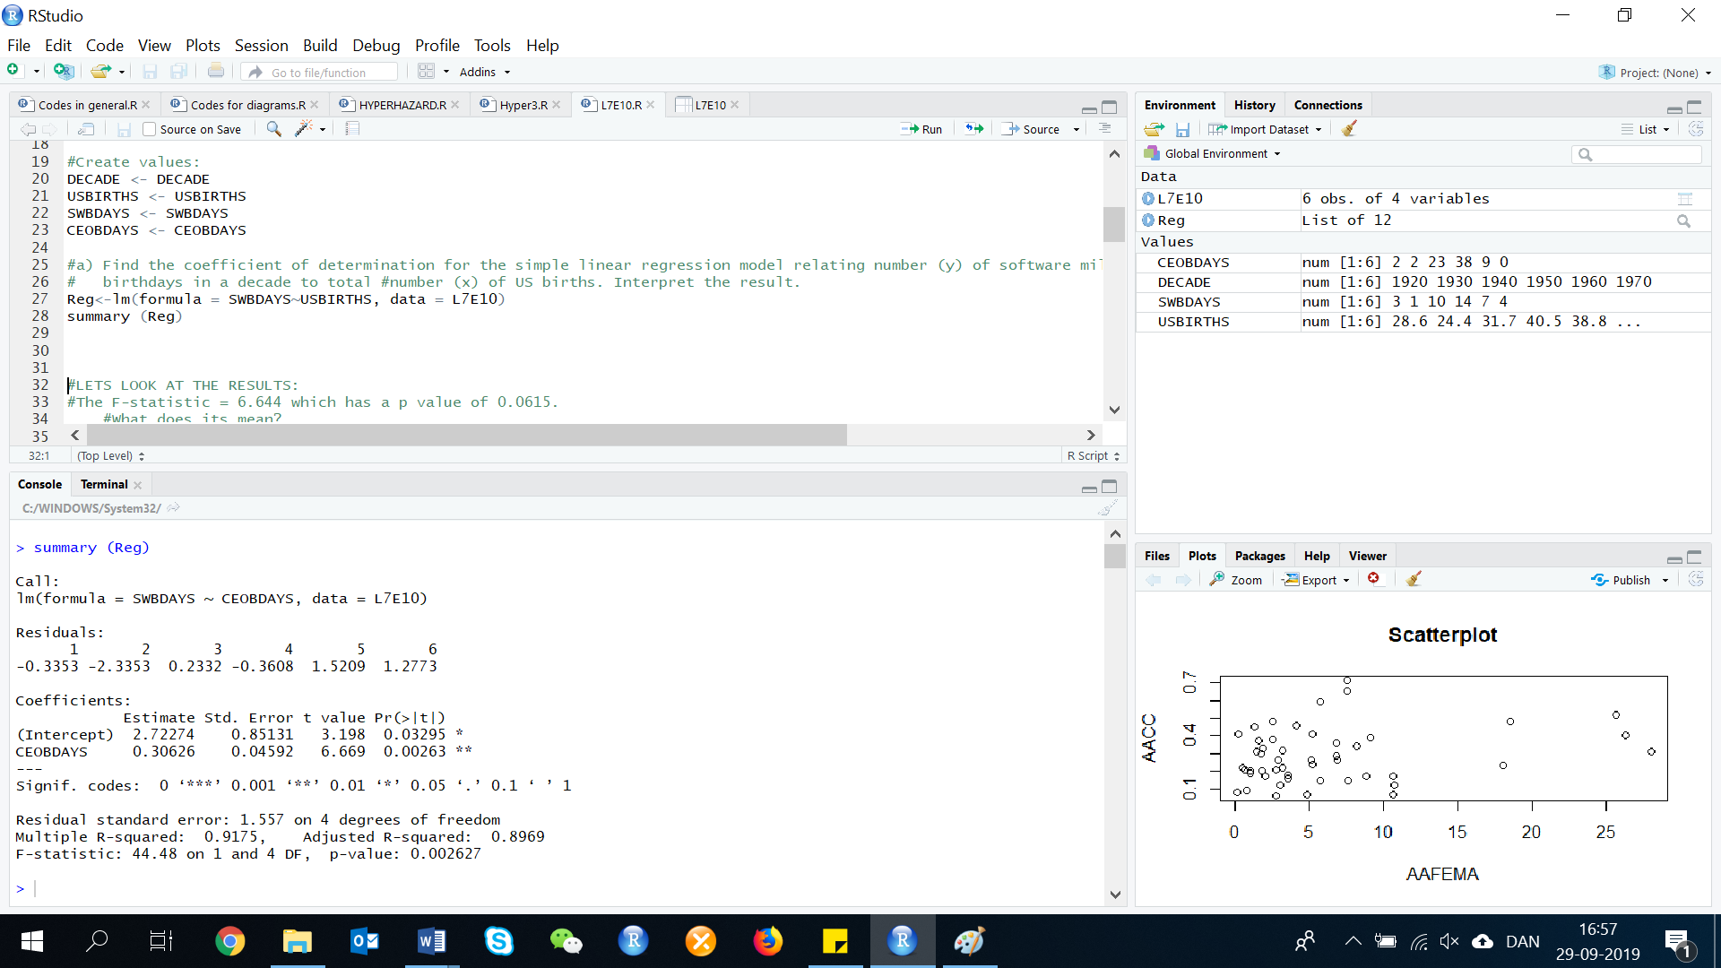

LETS LOOK AT THE RESULTS:

The F-statistic = 44.48 which has a p value of 0.002627, which is below 1.This implies that this model is statistically significant at the 1% significance level. CEO Birthdays explain the number of software millionaires births in 91.7%

We got Beta(0) at 2.7227, which is the estimate and intercept. And a t=3.198 with a p-value of 0.0330, which is below 5% significance. This means that this coefficient is statistically significant. There is evidence that this coefficient is different than 0.

We got Beta(1) at 0.3063, which is the estimate and CEOBdays. And t-test with a t-statistic of 6.669 and a p-value of 0.002627 which is lower than 1%. This means that this coefficient is significant at the 1% significance level. For every CEO birthday, 0.3063 software millionaires are born in average.

The multiplied R-squared (R^2) is 0.9175, 91.7%, of the total sample variability around the sample mean number of software millionaire birthdays is explained by the linear relationship between number of software millionaire birthdays and the total number of US births.

There are not guidelines as to when R^2 is large enough to conclude that the model is good. This depends on the case. However, it is to argue that an R^2 of 91.7% is high and therefore this is a good model for the data.

1. **The consulting statistician argued that the software industry appears to be no different from any other industry with respect to producing millionaires in a decade. Do you agree? Explain.**

Yes, there is a very strong positive linear relationship between the number of software millionaire birthdays and the number of CEO birthdays. As the number of software millionaire birthdays increase, the number of CEO birthdays also increase. This relation is statistically significant at the 5% significance level as it is shown by a p-value below 5% for the t-test of the slope of the regression.

**Exercise 11. (73, TOPBUS). *Survey on the top business schools*. Refer to the Wall Street Journal (Sep. 25, 2005) Business School Survey and the data saved in the file. Find and interpret r and r2 for the simple linear regression relating y = percentage of graduates with job offers and x = tuition cost and then fit the simple linear model.**

First, we need to do as followed:

1. Clean your screen
2. Import data
3. Create variables
4. Run Library(mosaic)

For explanation how to do this look at List 1, Exercise 1.

Clean R Script: rm(list=ls())

Library: library(mosaic)

Import data from Excel: library(readxl)

L7E11 <- read_excel("~/SDC/Quantitative Research Methods Course/Exercises/Dataset/List7/L7E11.xlsx")

View(L7E11)

attach(L7E11)

Create variables: School <- School

Enrollment <- Enrollment

Tuition_Dollar <- Tuition_Dollar

GMAT <- GMAT

JobOffer_Percent <- JobOffer_Percent

Salary_Dollar <- Salary_Dollar

To find the r and r2 for the simple linear regression of job offers and tuition costs, we run the following code for the regression model:

reg <- lm(JobOffer_Percent~Tuition_Dollar, data=L7E11)

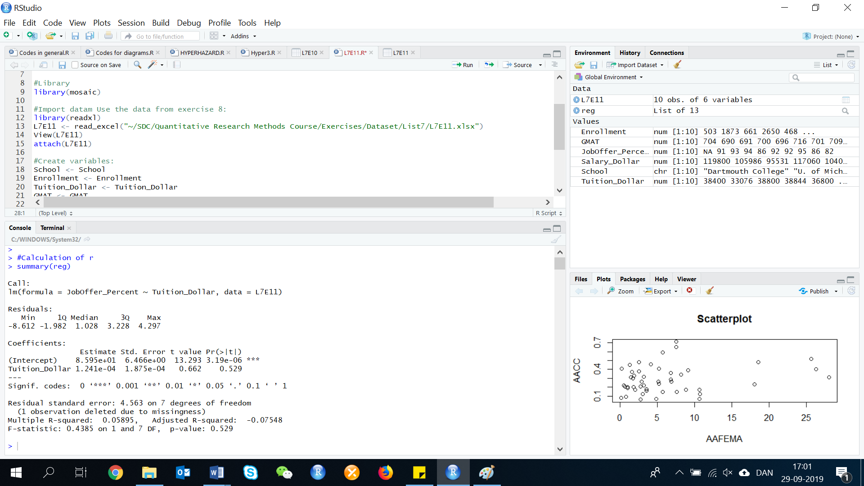summary(reg)

By looking at this regression analysis, we can see that R2=0.058955.9%.

We can use the R2 to calculate the R value:

sqrt(0.05895)=0.2427962

This means 5.9% of the variability in the percentage of graduates with job offers around the sample mean is explained by the linear relationship between percentage of graduates with job offers and tuition costs.

There is a weak positive linear relationship (or even no relationship) between percentage of graduates with job offers and tuition costs. You can see in the table above that X1 (the slope of the regression) is far to be statistically significant (high p-value of 0.52). Thus, we do not reject the hypothesis of the t-test over the slope, that this is different from 0.

Overall test of significance:

The regression model has a low F-value (close to 0) which has a high p-value of 0.5290. This implies that this model is not statistically significant.

Test of significance for the parameters:

B0= 85.9495, t-test with a very low p-value of less than 1%. This means that this coefficient is significant at the 1% significance level.

B1= 0.000124, t-test: t=0.66 with a high p-value of 0.5290 which is far above 1%, 5% or 10% of significance. This means that this coefficient is not statistically significant

The fitted regression line will therefore be:

$$\hat{y}=85.9495+0.000124x$$

**11.6 Using the model for estimation and prediction**

**Exercise 12. (86, PGA). *Ranking driving performance of professional golfers*. Refer to The Sport Journal (Winter 2007) study of a new method for ranking the total driving performance of golfers on the PGA tour, Exercise 21. You fit a straight-line model relating driving accuracy (*y*) to driving distance (*x*) to the data saved in the file. Of interest is predicting *y* and estimating *E(y)* when *x* = 300 yards*.***

First, we need to do as followed:

1. Clean your screen
2. Import data
3. Create variables
4. Run Library(mosaic)

For explanation how to do this look at List 1, Exercise 1.

Clean R Script: rm(list=ls())

Library: library(mosaic)

Import data from Excel: library(readxl)

L7E12 <- read_excel("~/SDC/Quantitative Research Methods Course/Exercises/Dataset/List7/L7E12.xlsx")

View(L7E12)

attach(L7E12)

Create variables: PLAYER <- PLAYER

DISTANCE <- DISTANCE

ACCURACY <- ACCURACY

INDEX <- INDEX

**a) Find and interpret a 95% prediction interval for *y.***

The equation for the confidence interval for y is:

$$\hat{y}±t_{0.025}(s)\sqrt{1+\frac{1}{n}+\frac{(x-\overline{x})^{2}}{{SS}_{xx}}}$$

To solve this exercise, we need to know the n, $\overline{x}$, ${SS}_{xx}$, s, and the $\hat{y}$. First, we need to calculate those values.

Calculation of n and mean:

length(DISTANCE)

n <- length(DISTANCE)

n=40

mean(DISTANCE)

mean=298.95

Calculation of SSxx:

sum(DISTANCE)

x <- sum(DISTANCE)

x= 11,958

SUMX2 <- (316.1^2)+(304.7^2)+(310.5^2)+ (311.7^2)+ (295.2^2)+ (301.4)^2+(301.0^2)+(299.2^2)+ (302.2^2)+ (300.2^2)+ (305.4^2)+(303.5^2) +(289.2^2)+ (300.1^2) +(301.1^2)+ (298.3^2)+ (300.8^2)+ (318.9^2)+ (291.3^2)+ (300.1^2) +(297.7^2)+ (288.2^2)+(300.6^2) +(291.8^2)+ (295.2^2) +(295.5^2)+ (283.2^2)+ (294.4^2)+ (302.3^2)+ (286.6^2) + (298.0^2) +(297.6^2)+ (294.1^2) +(296.8^2)+(290.0^2)+(291.0^2)+ (300.0^2)+ (298.9^2)+ (295.8^2)+ (309.4^2)

SUMX2=3,557,053

SSxx <- (SUMX2-((x^2)/n))

SSxx=2208.46

Calculation of s and $\hat{y}$:

reg <- lm(formula=ACCURACY ~ DISTANCE, data = L7E12)

summary(reg)

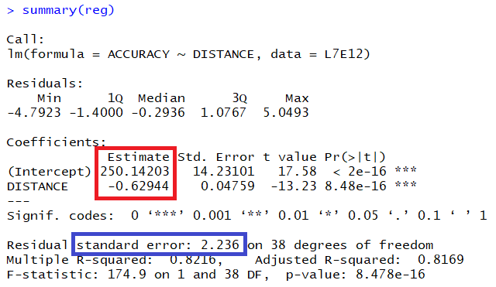

From the regression analysis we can see B0 and B1 (look at red box), that we need to make the $\hat{y}$ equation. Our intercept B0 = 250.14203, and the coefficient B1 = -0.62944.

$$\hat{y}=250.14203-0.62944x$$

By looking at the regression analysis, we can also see the s:

S=2.236

Now we are finished with the precalculations, and can move a bit forward in the calculation of the confidence interval.

If x=300, then:

$$\hat{y}=250.14203-0.62944*300=61.31003$$

We now have all the values, we need to calculate the confidence interval. For confidence coefficient 0.95, α=0.05 and α/2=0.05/2=0.025. The degrees of freedom for this analysis is df=n-2=40-2=38. When we look in the t table, we can se that t0.025=2.021. The 95% prediction/confidence interval is measured by:

$$\hat{y}±t_{0.025}(s)\sqrt{1+\frac{1}{n}+\frac{(x-\overline{x})^{2}}{{SS}_{xx}}}$$

Insert data:

$$61.31003±2.021*2.236\sqrt{1+\frac{1}{40}+\frac{(300-298.95)^{2}}{2208.46}}$$

61.31003+(2.021*2.236)*sqrt(1+(1/40)+((300-298.95)^2/2208.46))=65.88624

61.31003-(2.021*2.236)*sqrt(1+(1/40)+((300-298.95)^2/2208.46))=56.73382

Confidence interval: (56.73382, 65.88624)

We are 95% confident that the actual driving accuracy for a golfer who drives the ball 300 yards is between 56.73382 and 65.88624.

**b) Find and interpret a 95% confidence interval for *E(y).***

If x=300, then:

$$\hat{y}=250.14203-0.62944*300=61.31003$$

The 95% confidence interval for the mean is:

$$\hat{y}±t_{0.025}(s)\sqrt{\frac{1}{n}+\frac{(x-\overline{x})^{2}}{{SS}_{xx}}}$$

$$61.31003±2.021*2.236\sqrt{\frac{1}{40}+\frac{(300-298.95)^{2}}{2208.46}}$$

61.31003+(2.021*2.236)*sqrt((1/40)+((300-298.95)^2/2208.46))=62.03164

61.31003-(2.021*2.236)*sqrt((1/40)+((300-298.95)^2/2208.46))=60.58842

Confidence interval: (60.58842, 62.03164)

We are 95% confident that the mean driving accuracy for golfers who drive the ball 300 yards is between 60.58842 and 62.03164.

**c) If you are interested in knowing the average driving accuracy of all PGA golfers who have driving distance of 300 yards, which of the intervals is relevant? Explain.**

If we are interested in knowing the average driving accuracy of all PGA golfers who have a driving distance of 300 yards, we would use the confidence interval for E(y) or the mean found in part b. The prediction interval is a confidence interval for one golfer, not the mean of all golfers.

**11.7 A complete example**

**Exercise 13. (100, EBI). *Buying income and households*. Sales and Marketing Management determined the “effective buying income” (EBI) of the average household in a state. Can the EBI be used to predict retail sales per household in the store-group category “eating and drinking places”?**

|  |  |  |
| --- | --- | --- |
| **State** | **Average household buying income ($)** | **Retail sales: Eating and drinking places ($ per household)** |
| **Connecticut** | **60,998** | **2,553.8** |
| **New Jersey** | **63,853** | **2,154.8** |
| **Michigan** | **46,915** | **2,523.3** |
| **Minnesota** | **44,717** | **2,278.6** |
| **Florida** | **42,442** | **2,475.8** |
| **South Carolina** | **37,848** | **2,358.4** |
| **Mississippi** | **34,490** | **1,538.4** |
| **Oklahoma** | **34,830** | **2,063.1** |
| **Texas** | **44,729** | **2,363.5** |
| **Colorado** | **44,571** | **3,214.9** |
| **Utah** | **43,421** | **2,653.8** |
| **California** | **50,713** | **2,215.0** |
| **Oregon** | **40,597** | **2,144.0** |

First, we need to do as followed:

1. Clean your screen
2. Import data
3. Create variables
4. Run Library(mosaic)

For explanation how to do this look at List 1, Exercise 1.

Clean R Script: rm(list=ls())

Library: library(mosaic)

Import data from Excel: library(readxl)

L7E13 <- read_excel("~/SDC/Quantitative Research Methods Course/Exercises/Dataset/List7/L7E13.xlsx")

View(L7E13)

attach(L7E13)

Create variables: STATE <- STATE

AHBINCOME <- AHBINCOME

RETAILSALE <- RETAILSALE

**a) Use the data for 13 states given in the table below to find the least squares line relating retail sales per household (*y*) to average household EBI (*x*).**

There is two ways to calculate this:

Method 1: Calculating with R

To find the least squares line, we need to make a regression analysis:

reg <- lm(RETAILSALE~AHBINCOME, data=L7E13)

summary(reg)

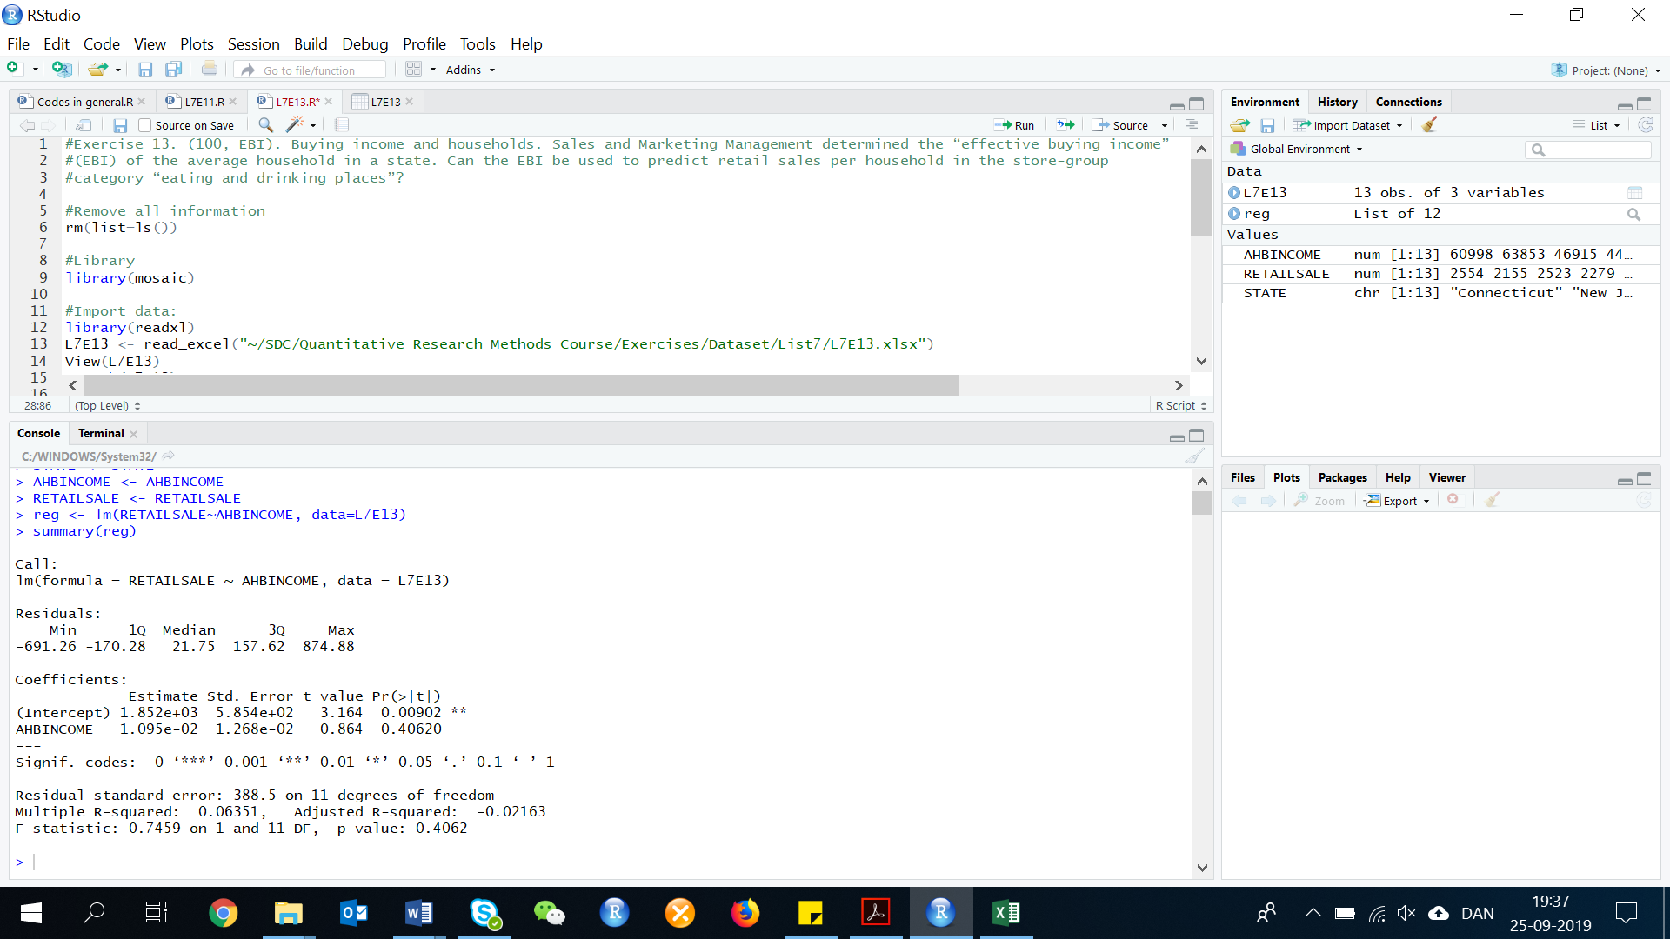

By looking at this regression analysis, we can see that the intercept is:

$$\hat{y}=1852+0.01095x$$

Method 2: Manually

Look at List 7, Exercise 3 for further explanation how to calculate the values below.

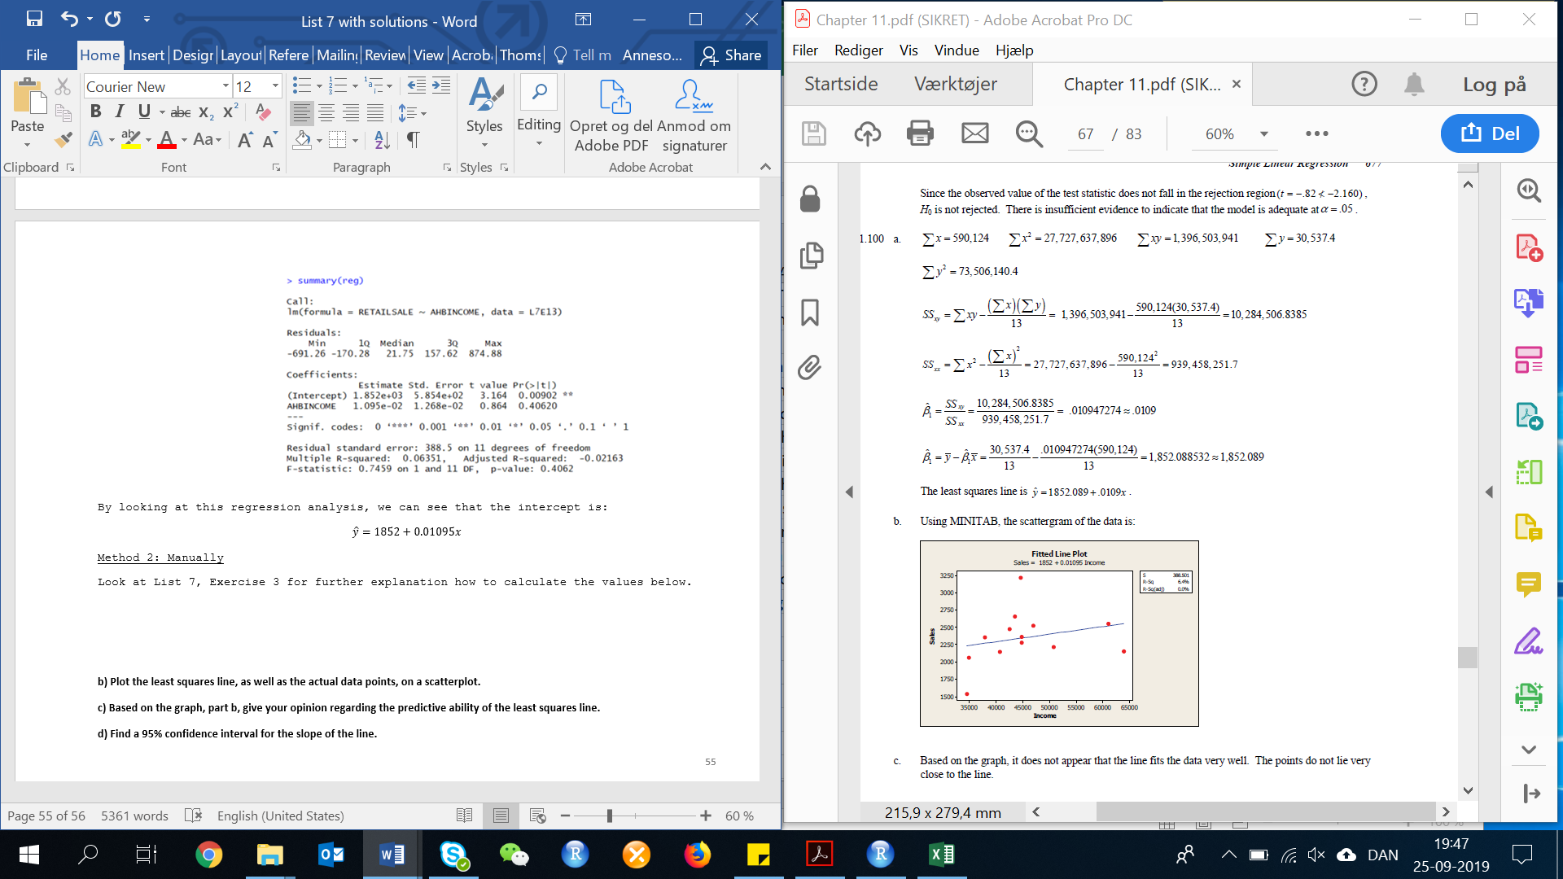

**b) Plot the least squares line, as well as the actual data points, on a scatterplot.**

plot(AHBINCOME, RETAILSALE, main="Fitted Line Plot", xlab="Sales", ylab="Income")

lines(AHBINCOME, fitted(reg), col="red")

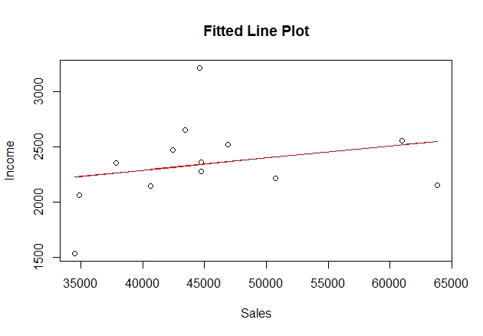

**c) Based on the graph, part b, give your opinion regarding the predictive ability of the least squares line.**

Based on the graph, it does not appear that the line fits the data very well. The points do not lie very close to the line.

**d) Find a 95% confidence interval for the slope of the line.**

There is two ways to calculate this. We will go through have you can calculate this in R:

Use your regression analysis in the code confint() to calculate the 95% confidence interval for the slope of the line:

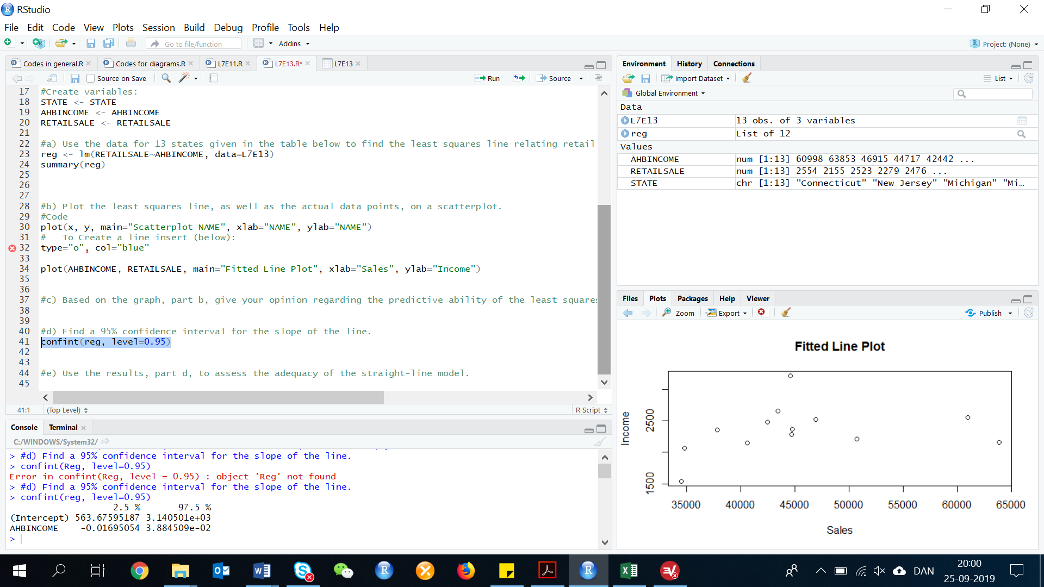confint(reg, level=0.95)

This analysis shows us that the confidence interval is:

Confidence interval: (-0.01695054, 0.03884509)

**e) Use the results, part d, to assess the adequacy of the straight-line model.**

Since 0 is contained in the 95% confidence interval, there is no evidence to indicate that there is linear relationship between buying income and retail sales.